### VIVEKANAND EDUCATION SOCIETY’S INSTITUTE OF TECHNOLOGY

**(An Autonomous Institute Affiliated to University of Mumbai)**

#### Department of Computer Engineering

###### 

###### Project Report on

**PlanItUrban: Shaping future**

**together for better City**

Submitted in partial fulfillment of the requirements of Third Year (Semester–VI), Bachelor of Engineering Degree in Computer Engineering at the University of Mumbai Academic Year 2024-25

By

**Gayatri Wadhwani (D12B/62)**

**Nishika Ahuja (D12B/02)**

**Simran Gurdasani (D12A/28)**

**Hainy Chughria (D12C/67)**

**Project Mentor**

Prof. Indu Dokare

## University of Mumbai

## (AY 2024-25)

**VIVEKANAND EDUCATION SOCIETY’S INSTITUTE OF TECHNOLOGY**

**(An Autonomous Institute Affiliated to University of Mumbai)**

**Department of Computer Engineering**



# CERTIFICATE

This is to certify that **Gayatri Wadhwani (D12B/62), Nishika Ahuja (D12B/02), Simran Gurdasani (D12A/28)**, **Hainy Chughria (D12C/67)** of Third Year Computer Engineering studying under the University of Mumbai has satisfactorily presented the project on “**PlanItUrban: Shaping future together for better City**” as a part of the coursework of Mini Project 2B for Semester-VI under the guidance of **Prof. Indu Dokare** in the year 2024-25.



Date

|  |  |  |
| --- | --- | --- |
| Internal Examiner |  | External Examiner |



Project Mentor Head of the Department Principal

Dr. Mrs. Nupur Giri Dr. Mrs. J. M.Nair

Declaration

We declare that this written submission represents our ideas in our own words and where others' ideas or words have been included, we have adequately cited and referenced the original sources. We also declare that we have adhered to all principles of academic honesty and integrity and have not misrepresented or fabricated or falsified any idea / data / fact / source in our submission. We understand that any violation of the above will be cause for disciplinary action by the Institute and can also evoke penal action from the sources which have thus not been properly cited or from whom proper permission has not been taken when needed.

| (Signature)  Gayatri Wadhwani (D12B/62) | (Signature)  Nishika Ahuja (D12B/02) |
| --- | --- |
| (Signature)  Simran Gurdasani (D12A/28) | (Signature)  Hainy Chughria (D12C/67) |

Date:

### ACKNOWLEDGEMENT

We are thankful to our college Vivekanand Education Society’s Institute of Technology for considering our project and extending help at all stages needed during our work of collecting information regarding the project.

It gives us immense pleasure to express our deep and sincere gratitude to Assistant Professor **Mrs. Indu Dokare** for her kind help and valuable advice during the development of project synopsis and for her guidance and suggestions.

We are deeply indebted to the Head of the Computer Department **Dr. (Mrs.) Nupur Giri** and our Principal **Dr. (Mrs.) J.M. Nair ,** for giving us this valuable opportunity to do this project.

We express our hearty thanks to them for their assistance without which it would have been difficult in finishing this project synopsis and project review successfully.

We convey our deep sense of gratitude to all teaching and non-teaching staff for their constant encouragement, support and selfless help throughout the project work. It is a great pleasure to acknowledge the help and suggestion, which we received from the Department of Computer Engineering.

We wish to express our profound thanks to all those who helped us in gathering information about the project. Our families too have provided moral support and encouragement several times.

#### Computer Engineering Department

**COURSE OUTCOMES FOR T.E MINI PROJECT 2B**

Learners will be to:-

| **CO No.** | **COURSE OUTCOME** |
| --- | --- |
| CO1 | Identify problems based on societal /research needs. |
| CO2 | Apply Knowledge and skill to solve societal problems in a group. |
| CO3 | Develop interpersonal skills to work as a member of a group or leader. |
| CO4 | Draw the proper inferences from available results through theoretical/  experimental/simulations. |
| CO5 | Analyze the impact of solutions in societal and environmental  context for sustainable development. |
| CO6 | Use standard norms of engineering practices |
| CO7 | Excel in written and oral communication. |
| CO8 | Demonstrate capabilities of self-learning in a group, which leads to  lifelong learning. |
| CO9 | Demonstrate project management principles during project work. |

**Index**

| **Title** | **Page No.** |
| --- | --- |
| **Abstract** | 1 |
| **Chapter 1: Introduction** | 2 |
| 1.1 Introduction | 3 |
| 1.2 Motivation | 3 |
| 1.3 Problem Definition | 3 |
| 1.4 Existing Systems | 4 |
| 1.5 Lacunas of the existing systems | 5 |
| 1.6 Relevance of the Project | 6 |
| **Chapter 2: Literature Survey** | 7 |
| 2.1 Overview of Literature Survey | 7 |
| 2.2 Related Works | 7 |
| 2.3 Research Papers Referred | 8 |
| 2.3.1 Abstract of the research paper |  |
| 2.3.2 Inference drawn |  |
| 2.4 Patent search | 8 |
| 2.5 Inference drawn | 9 |
| 2.6 Comparison with the existing system | 9 |
| **Chapter 3: Requirement Gathering for the Proposed System** | 11 |
| 3.1 Introduction to requirement gathering | 11 |
| 3.2 Functional Requirements | 11 |
| 3.3 Non-Functional Requirements | 11 |
| 3.4 Hardware, Software, Technology and tools utilized | 12 |
| 3.5 Constraints | 12 |
| **Chapter 4: Proposed Design** | 13 |
| 4.1 Block diagram of the system | 13 |
| 4.2 Modular design of the system | 14 |
| **Chapter 5: Implementation of the Proposed System** | 16 |
| 5.1 Methodology Employed | 16 |
| 5.2 Algorithms and flowcharts | 17 |
| **Chapter 6: Testing of the Proposed System** | 20 |
| 6.1 Introduction to testing | 20 |
| 6.2 Types of tests Considered | 20 |
| 6.3 Various test case scenarios considered | 20 |
| 6.4 Inference drawn from the test cases | 20 |
| **Chapter 7: Results and Discussion** | 21 |
| 7.1 Screenshots of User Interface (GUI) | 21 |
| 7.2 Performance Evaluation measures | 30 |
| 7.3 Input Parameters / Features considered | 30 |
| 7.4 Inference drawn | 31 |
| **Chapter 8: Conclusion** | 32 |
| 8.1 Limitations | 32 |
| 8.2 Conclusion | 32 |
| 8.3 Future Scope | 32 |
| **References** | 34 |
| **Appendix**   1. List of Figures 2. List of Tables 3. Paper Publication 4. Project review sheets | 36 |

**Appendix**

1. **List of Figures**

| Figure Number | Heading | Page No. |
| --- | --- | --- |
| 4.1.1 | Block diagram architecture of the PlanItUrban system | 13 |
| 4.2.1 | PlanItUrban system workflow diagram | 14 |
| 5.2.1 | PlanItUrban Platform - System Flow Diagram | 18 |
| 7.1.1 | Home Page | 21 |
| 7.1.2 | Signup Page | 21 |
| 7.1.3.1 | Commissioner Dashboard Page | 22 |
| 7.1.3.2 | Commissioner Dashboard Page | 22 |
| 7.1.4 | View Project Requests Page | 23 |
| 7.1.5 | View All Projects Page | 23 |
| 7.1.6 | Map Page | 24 |
| 7.1.7.1 | Department Dashboard | 24 |
| 7.1.7.2 | Department Dashboard | 24 |
| 7.1.8.1 | Chatbot | 25 |
| 7.1.8.2 | Chatbot | 25 |
| 7.1.9 | Add A Project | 26 |
| 7.1.10 | View All Projects Page | 27 |
| 7.1.11 | Add a Officer Page | 27 |
| 7.1.12 | Add a task Page | 28 |
| 7.1.13 | Dashboard Page(Officer) | 28 |
| 7.1.14 | View all projects Page | 29 |
| 7.1.15 | Notifications Page | 29 |
| 7.1.16 | Assigned tasks Page | 30 |

1. **List of tables**

| Table Number | Heading | Page no. |
| --- | --- | --- |
| 2.4.1 | Comparison with existing works | 10 |
| 6.3.1 | Test Cases | 20 |

1. **Paper Publication**
2. **Project review sheets**

# ABSTRACT

Urban governance in India is often hindered by fragmented departmental structures and poor interdepartmental coordination. These challenges frequently lead to project delays and overlapping responsibilities among departments such as Water Supply, Public Works, and Sanitation, all of which undermine the efficient execution of urban projects. The lack of communication and cooperation between these departments results in infrastructural inefficiencies that hamper development efforts across Indian cities.

To address these issues, PlanItUrban is proposed as an innovative digital platform designed to streamline governance processes by enhancing interdepartmental collaboration. The platform’s key objectives are to improve coordination through real-time data sharing, by leveraging AI-driven decision-making, foster transparency in project execution and enable proactive conflict resolution through data analytics. By integrating these tools, PlanItUrban aims to eliminate the inefficiencies that commonly arise in fragmented governance structures, ensuring that projects are completed on time and within budget.

Additionally, PlanItUrban aligns with global smart city trends by fostering transparency, accountability, and informed decision-making in urban planning. Drawing from successful case studies in cities like Kansas City and Dhaka, the platform incorporates strategies to mitigate delays and inefficiencies while enabling scalability and adaptability across various urban environments. With its potential for expansion, PlanItUrban stands as a promising model for sustainable urban governance in India, capable of transforming the way cities operate.

## Chapter 1: Introduction

**1.1 Introduction**

The PlanItUrban project aims to create a digital platform that enhances interdepartmental collaboration and streamlines urban governance in Indian cities. Traditionally, urban governance in India faces challenges due to fragmented departmental structures and leading to project delays and ineffective coordination among critical urban departments like Water Supply, Public Works, and Sanitation [3]. PlanItUrban addresses these issues by facilitating seamless coordination, enabling departments to communicate in real-time, assign tasks efficiently, and track the progress of ongoing infrastructure projects. This real-time data-sharing mechanism can mitigate common issues, such as project overlap and delays, by ensuring departments remain informed and aligned with project timelines [2].

The platform provides distinct user roles—Commissioner, Departments, and Officers—each responsible for different levels of project management, task assignment. This role-based structure ensures accountability while minimizing the bureaucratic bottlenecks that often hinder interdepartmental coordination. Additionally, the platform enables easy documentation of progress, allowing departments to maintain up-to-date records, which reduces the risk of miscommunication and enhances project transparency [1].

Research on e-governance and digital platforms highlights the role of such tools in improving transparency, accountability, and efficiency in urban governance [5]. For instance, studies on urban planning in India have demonstrated that digital platforms can help address challenges in governance by fostering citizen engagement and improving the coordination of government projects [14]. Similarly, platforms in cities like Kansas City and Dhaka have shown how digital technology can enhance transparency and reduce project delays by providing a centralized communication system for departments and stakeholders [14].

Furthermore, PlanItUrban incorporates AI-driven decision-making tools, allowing departments to detect potential conflicts and make proactive decisions to prevent project disruptions [8]. AI-based planning and real-time data analytics ensure that the platform can predict issues like overlapping timelines enabling departments to adjust plans before significant delays occur. The growing global emphasis on smart city development supports the implementation of AI-driven platforms like PlanItUrban, which align with current trends in urban planning [10].

**1.2 Motivation**

Urban governance is crucial for enhancing public services and infrastructure, which directly contribute to economic growth and stability. In India, fragmented departmental structures often lead to inefficiencies, project delays. PlanItUrban is designed to address these challenges by creating a digital platform that streamlines interdepartmental collaboration. By enabling real-time data sharing and communication across departments like Water Supply and Public Works, the platform aims to reduce delays and improve overall project execution [1].

Integrating operations research (OR) into urban planning can further enhance the effectiveness and social impact of platforms like PlanItUrban. While OR has traditionally focused on urban issues such as transportation and housing, its application in urban governance has been limited compared to public policy [6]. By adopting a more inclusive OR approach that prioritizes community engagement and methodological pluralism, PlanItUrban can address the complex, multi-stakeholder nature of urban environments. This perspective not only recognizes the diverse voices of community members but also aims to develop equitable solutions to urban challenges by incorporating qualitative methods alongside technological innovations [5].

Additionally, efficient governance plays a key role in promoting sustainability and preserving cultural heritage. By streamlining project management, PlanItUrban supports sustainable urban development, ensuring that modern infrastructure projects align with environmental and cultural conservation goals [9]. The platform’s scalability makes it a valuable model for future expansions, benefiting current and future generations by fostering transparency and efficient governance [7].

**1.3 Problem Definition**

The rapid urbanization of Indian cities has led to increased demand for efficient infrastructure and public services. However, the existing governance framework often suffers from fragmentation, with multiple departments operating in isolation. This lack of coordination results in overlapping responsibilities, project delays. For instance, a newly constructed road can be disrupted by the later installation of utility lines, highlighting the inefficiencies inherent in a fragmented governance system that ultimately affects the quality of urban services provided to residents [4].

Research on urban planning in Dhaka, Bangladesh, further emphasizes the importance of coordinated governance structures for effective urban management. Despite the theoretical advantages of decentralization, the lack of alignment among various planning bodies—such as the Dhaka City Corporation and the Capital Development Authority—has led to inefficiencies and poor urban management [14]. Overlapping roles and responsibilities among these organizations hinder effective planning and service delivery, resulting in fragmented efforts that do not align with the city's development goals [6][7].

In response to these challenges, there is a pressing need for a centralized digital platform to facilitate interdepartmental cooperation. The objectives of PlanItUrban include improving urban governance, streamlining project execution, and ultimately ensuring that urban projects are completed efficiently and effectively to meet the growing needs of residents.

##### 1.4 Existing Systems

Currently, most urban infrastructure projects are managed through fragmented systems or manual processes [8]. Various government departments operate in silos, each using their own isolated methods for project planning, approvals, and communication. Below are some observations from existing systems:

### Manual and Paper-Based Processes

* Officer registration, project approvals often rely on physical paperwork.
* Lack of digitalization leads to significant delays and human errors.

### Department-Specific Tools

* Some departments use basic tools like spreadsheets or localized software.
* These tools do not support integration with other departments, resulting in poor visibility and coordination.

### No Conflict Detection Mechanism

* Overlapping infrastructure work (e.g., road construction and utility installation) often goes unnoticed until conflicts arise on ground.
* Existing systems do not include GIS-based or AI-based detection to prevent such issues.

### Limited or No Real-Time Tracking

* Projects are rarely monitored in real time, making it difficult for officials to track progress or bottlenecks.
* Delays or overruns are often identified too late to take corrective actions.

##### 1.5 Lacunas of the Existing Systems

1. **Fragmented Communication**

Government departments often work in isolation without a unified communication platform. This leads to frequent miscommunication, redundant efforts [3].

Example: The Public Works Department completes the construction of a road, but due to a lack of information sharing, the Water Resources Department later digs up the same road to install pipelines, leading to repeated costs and disruption.

1. **Uncoordinated Project Execution**

Simultaneous execution of unrelated projects without proper coordination often results in conflicts and delays [5][6]. Departments may unknowingly plan projects in the same area or timeframe, causing disruption in workflows and public inconvenience.

Example: A railway infrastructure project and a major road expansion project happening together in the same region cause bottlenecks, delaying both initiatives.

1. **Manual and Delayed Approval Processes**

Traditional approval systems depend heavily on in-person document submissions and manual verifications, leading to slow processes and increased administrative burden [8].

Example: Officers are often required to physically visit government offices multiple times for project approvals or registration, wasting time and slowing down project kick-offs.

1. **Inefficient Project Tracking**

Without an integrated tracking and reporting system, it becomes difficult to monitor ongoing projects, detect issues early, and make data-driven decisions [10]. This often leads to unmanaged risks, cost overruns, and missed deadlines.

Example: A road construction project faces unexpected delays due to unplanned utility maintenance, but the lack of a real-time monitoring system causes late issue detection, resulting in project cost escalation and timeline disruption.

##### 1.6 Relevance of the Project

##### The relevance of the PlanItUrban project lies in its ability to solve major bottlenecks in urban governance, especially the challenges of fragmented communication, uncoordinated project execution, slow manual approvals, and inefficient project tracking [4]. As urban areas rapidly expand, particularly in countries like India, coordinated governance becomes crucial for sustainable, efficient city development., The relevance is highlighted as follows:

* **Improved Interdepartmental Communication:** PlanItUrban offers a centralized digital platform where departments can share information and collaborate in real time. It addresses the long-standing issue of isolated workflows that often lead to conflicts like road construction being damaged by later pipeline installations [5].
* **Better Coordination in Project Execution:** By mapping and tracking all ongoing and proposed projects on a unified system, PlanItUrban minimizes the risk of overlapping activities, thereby reducing delays and enhancing the effectiveness of project delivery.
* **Faster and Transparent Approval Processes:** The platform digitizes officer registration, project approvals, and task assignments, replacing traditional manual methods with efficient workflows [7][8]. This significantly cuts down on approval times and reduces the burden on both officers and administrators.
* **Efficient Monitoring and Issue Management:** With real-time project dashboards, conflict detection alerts, and progress tracking, PlanItUrban ensures timely identification and resolution of potential problems. This proactive approach prevents cost overruns and project mismanagement, making urban development faster and more reliable [5].

By addressing these critical gaps, PlanItUrban stands out as a transformative solution for smarter, more integrated urban governance.

## Chapter 2: Literature Survey

##### A. Overview

This literature survey investigates prior innovations and academic research concerning interdepartmental urban project coordination, digital governance frameworks, and intelligent infrastructure planning [9]. Existing municipal systems are often hindered by fragmented communication, delayed approvals, and inefficient tracking mechanisms. These gaps contribute to overlapping projects. The PlanItUrban system is designed to resolve these challenges by drawing upon digital integration, AI assistance, and geospatial awareness—offering a unified solution for efficient urban project execution [10].

##### B. Related Works

PlanItUrban draws inspiration and technical direction from multiple pioneering efforts in smart city governance, geospatial coordination, and AI-driven urban planning:

* **"An IoT-Based Smart City Framework for Efficient Urban Governance"**This paper details how sensor-based data and IoT systems can unify city services and offer real-time monitoring across departments. Inspired by this, PlanItUrban includes real-time project updates and department-wise notifications for improved transparency and decision-making [9].
* **"Integrated Platform for Urban Project Management using Geospatial Technology"**This study presents a GIS-backed coordination system to track infrastructure development and avoid overlaps. PlanItUrban mirrors this by integrating Google Maps to visually manage project sites and identify conflict zones [8].
* **"Enhancing Urban Infrastructure Through E-Governance Portals"** This paper emphasizes the impact of digital tools on transparency and departmental coordination. Similarly, PlanItUrban supports structured approval workflows, officer authentication, and dashboard-driven monitoring to streamline governance operations [6].

##### 2.1 Research Paper referred

The Abstract and Inference of research paper referred are discussed below:

1. **“Digital Infrastructure for Smart Cities” – M. Singh & R. Gupta**

* **Abstract:** This study examines integrated digital platforms in cities like Pune and Surat. It proves how real-time systems minimize project delays.
* **Inference:** Interdepartmental platforms significantly enhance execution and minimize operational conflicts [5].

1. **“GIS-Based Urban Planning System” by T. Ramesh and K. Patel**

* **Abstract:** Presents a spatially aware project management system. It overlays infrastructure tasks to identify and resolve clashes before execution.
* **Inference:** GIS tools enhance visual planning and prevent overlapping tasks, such as roadworks and utility setups [10].

1. **“E-Governance Frameworks for Municipal Coordination” by A. Bose et al.**

* **Abstract:** Focuses on centralized digital systems for project tracking and meeting management. Results indicate improved accountability and faster task completion.
* **Inference:** E-governance systems ensure transparency and improve departmental collaboration [11].

1. **“Smart Collaboration: Resolving Urban Infrastructure Conflicts using AI” by P. Iyer and V. Menon**

* **Abstract:** Introduces AI-based conflict detection in infrastructure projects by analyzing interdepartmental data for early warnings.
* **Inference:** AI integration can prevent redundant work by identifying potential project clashes in early planning stages [12].

**2.2 Patent Search**

To inform the development of PlanItUrban, a thorough patent search was conducted to identify relevant existing technologies that could enhance the platform's functionality.

The patent Smart City Infrastructure Coordination Platform [16] by B. D. Koch and M. J. Skurla describes a digital system for coordinating utility projects using GPS data and cross-departmental scheduling. This system supports features such as project overlap detection and GIS integration, which are highly relevant to PlanItUrban's need for seamless infrastructure management and real-time coordination between urban planning departments.

Another significant patent, Real-Time Municipal Project Tracker [17], authored by S. A. Mize and J. M. Voss, focuses on real-time task assignment and progress tracking for civic departments. The features outlined in this patent align closely with PlanItUrban’s objective of creating a dynamic task tracking and officer dashboard system, which will enable continuous monitoring and efficient management of urban projects.

Additionally, the Indian patent Method and System for Managing One or More Processes in an Organization [18], filed by G. Nadkarni et al., proposes a workflow system for managing municipal processes through centralized document control and secure approval workflows. This patent mirrors several features planned for PlanItUrban, including secure document handling and approval mechanisms for city commissioners and other stakeholders.

**2.3 Inference Drawn**

From the literature and patent survey, the following key insights have been derived:

* Fragmented governance leads to costly delays, redundant tasks, and unplanned overlaps.
* GIS and AI can significantly reduce project conflicts and enhance decision-making [9].
* E-Governance systems with structured workflows improve transparency and accountability.
* Real-time updates and centralized dashboards are crucial for efficient urban planning.

**2.4 Comparison with existing systems**

Table 2.4.1 depicts the comparison between traditional urban planning systems and the proposed PlanItUrban platform. Traditional urban planning systems are often siloed, with departmental communication and manual project approvals, leading to slow processes and ad hoc detection of project overlaps. Task assignment and updates are typically handled manually. Visualization tools are rarely used, and citizen engagement is usually limited to external e-governance platforms. In contrast, PlanItUrban offers a unified platform with interdepartmental notifications, automated digital workflows for project approvals, AI-powered conflict detection integrated with GIS mapping, and an officer dashboard for real-time task tracking.

Table 2.4.1. Comparison with existing works

| **Feature** | **Traditional Systems** | **PlanItUrban** |
| --- | --- | --- |
| Communication | Siloed, departmental | Unified, interdepartmental notifications |
| Project Approval | Manual, slow | Automated digital workflows |
| Project Overlap Detection | Lacking or ad hoc | AI-based conflict detection + GIS mapping |
| Conflict Management | Manual, Traditional | Recommendation System to help entity named Commissioner |
| Task Assignment & Tracking | Manual updates | Officer dashboard with real-time task progress |
| Visualization | Not commonly used | Google Maps-based spatial visualization |
| Citizen Engagement | External e-governance platforms only | Internal dashboards and secure access for officials |

## Chapter 3. Requirement gathering for proposed system

## 

##### 3.1 Introduction to Requirement Gathering

The PlanItUrban project, aimed at resolving inefficiencies in urban project coordination across government departments, began with recognizing the fragmented nature of interdepartmental planning in Indian cities [3]. Requirement gathering focused on clearly defining the need for a unified digital solution that supports centralized communication, conflict detection, and real-time collaboration. The project aimed to reduce project delays, overlapping efforts by enabling seamless coordination among departments such as water, electricity, roads, and telecom.

##### 3.2 Functional Requirements

The PlanItUrban platform enables urban departments to register, manage, and track projects while facilitating real-time conflict detection and collaboration. Key features include user authentication, role-based access (admin, department heads, officers), and a shared dashboard to visualize project progress. A conflict detection system identifies overlapping projects by geography and timelines, triggering automated alerts for timely coordination.

AI tools for proactive conflict resolution, secure document management, and communication are integrated into the platform. Automated notifications are sent to address potential project overlaps or delays, ensuring quick resolution. The system also supports detailed project data entry, milestone tracking, and transparent reporting, aiming to streamline governance, reduce inefficiencies, and ensure timely project completion in line with smart city goals.

##### 3.3 Non Functional Requirements

The system must demonstrate high reliability, ensuring 24/7 availability for government use. Usability is critical, requiring an intuitive interface for users with varying degrees of digital proficiency. Scalability is also essential, allowing the system to accommodate multiple cities, departments, and growing project volumes. Security is paramount, with role-based access control and secure login mechanisms to protect sensitive infrastructure data [7].

In addition, performance requirements include fast response times for conflict detection. Lastly, the solution must be cost-effective to ensure feasibility for widespread adoption by municipal bodies with limited technical infrastructure.

##### 3.4 Hardware, Software, Technology and Tools Utilized

**Hardware Requirements**

The PlanItUrban platform requires specific hardware to ensure optimal performance and user engagement. Hardware Requirements are, a Pentium or Intel processor is recommended for smooth operations. Additionally, at least 4GB of RAM is necessary for multitasking and efficient data handling. A hard disk with a minimum capacity of 20GB is required for storing project-related data, while a screen resolution of at least 1280x1024 pixels ensures clear visibility of the platform's interface.

**Software Requirements**

The PlanItUrban platform also requires specific software for its optimal functioning. The frontend is developed using Angular, which enables a responsive and interactive user interface. The platform uses a MySQL database to manage and store data effectively, ensuring that all project information is easily accessible. The backend is built on Spring Boot, a powerful framework that ensures secure data transactions and supports the overall reliability and scalability of the platform. Also the platform has used Flask for recommendation System. These software specifications work together to streamline interdepartmental collaboration and improve the efficiency of urban project management.

##### 3.5 Constraints

* **Limited Stakeholder Access:** Involving all departments across different regions posed logistical and technical difficulties, potentially leading to incomplete requirement analysis.
* **Data Inconsistency:** Variability in data formats and project reporting structures across departments hindered seamless integration.
* **Technological Resistance:** Adoption may be slow due to reluctance in shifting away from manual coordination methods and existing legacy tools.

## Chapter 4. Proposed Design

##### 4.1 Block Diagram

The architecture of the PlanItUrban system is designed to streamline urban governance, facilitating smooth coordination between different user roles and core functional modules. It provides an overview of the system's key components, illustrating how each part works together to ensure efficient project management and task execution.

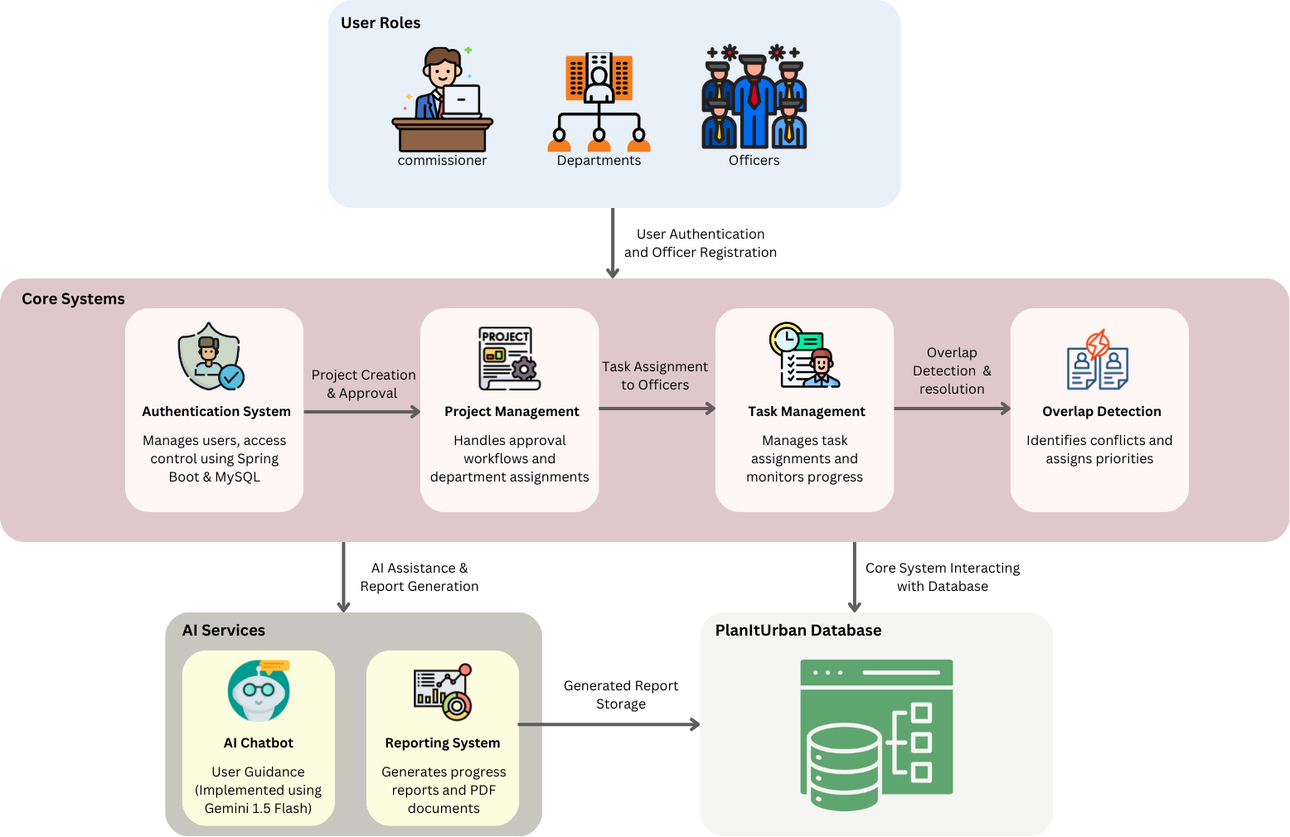

Fig. 4.1.1 Block diagram architecture of the PlanItUrban system

Fig. 4.1.1 provides a modular overview of the entire PlanItUrban system. At the top are User Roles (Commissioner, Departments, Officers). Below that are Core Systems including Authentication System, Project Creation & Approval, Project Management, Task Assignment, Task Management, and Overlap Detection. These core systems interact with AI Services (AI Chatbot and Reporting System) and the PlanItUrban Database. The diagram illustrates how different components interconnect to form the complete system architecture, showing data flow between modules and the relationship between user roles and system functionality.

##### 4.2 Modular Diagram

The modular diagram of the PlanItUrban system provides an in-depth view of how the different modules and processes are interconnected. It showcases the system’s workflow, emphasizing how the user interface interacts with core functional modules to support efficient project and task management.

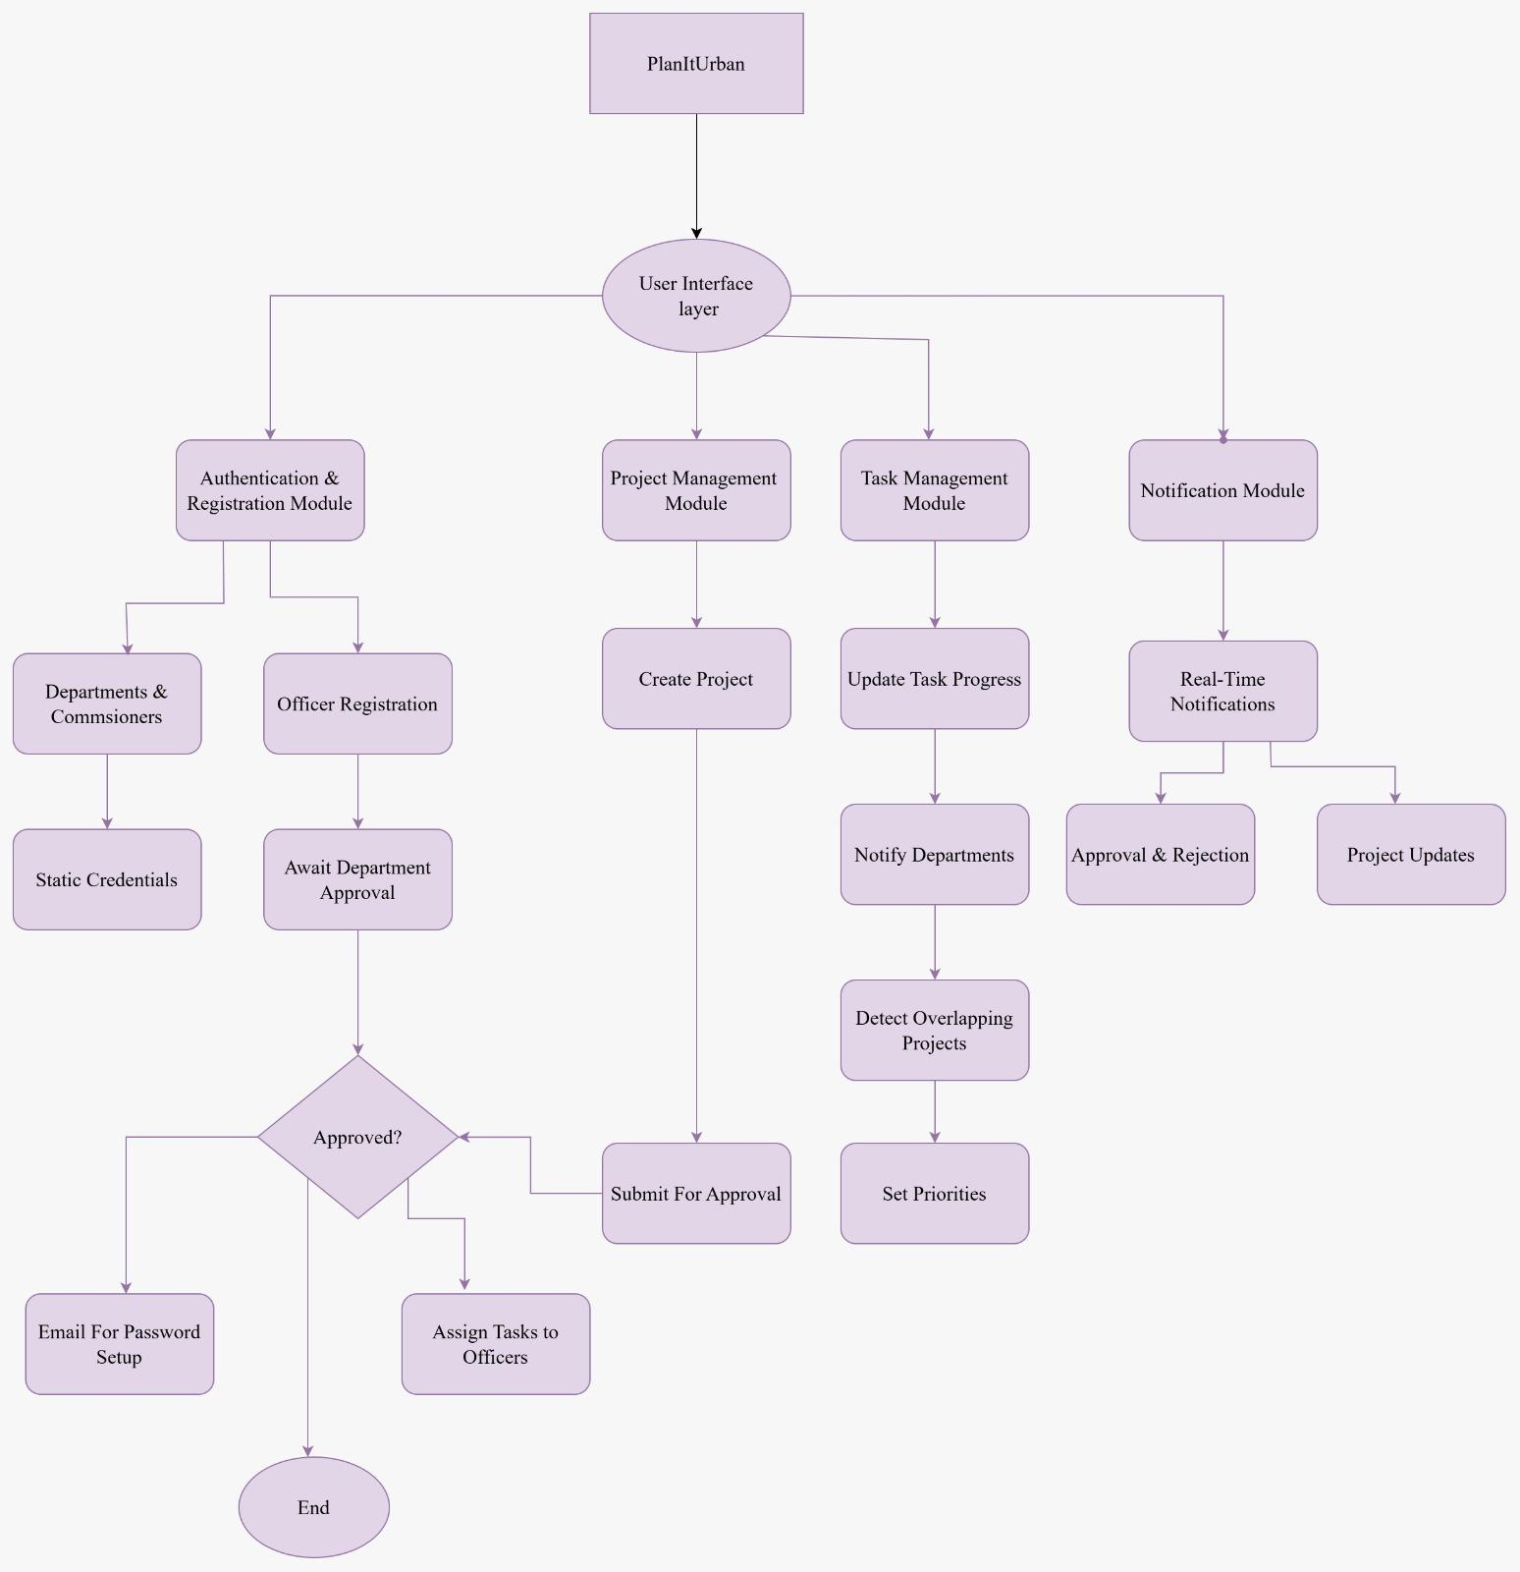

Fig. 4.2.1 PlanItUrban system workflow diagram

Fig. 4.2.1 presents a comprehensive flowchart of the PlanItUrban system architecture, integrating all major modules and their interactions. Starting with PlanItUrban at the top, it flows down to the User Interface layer which branches into four primary modules: Authentication & Registration Module, Project Management Module, Task Management Module, and Notification Module. Each module then expands into its specific functions: Authentication handles Departments/Commissioners and Officer Registration paths (including approval workflows and credential management); Project Management oversees project creation, submission, and approval processes; Task Management covers progress updates, department notifications, and overlap detection with priority settings; while the Notification Module manages real-time alerts for approvals, rejections, and project updates. The diagram illustrates how these components interconnect to form a cohesive workflow, with approval decision points directing the flow to either email setup or task assignment, ultimately converging to an end point that completes the system's operational cycle.

## Chapter 5: Implementation of the Proposed System

##### 5.1 Methodology Employed

PlanItUrban is a digital solution designed to streamline interdepartmental coordination for urban infrastructure projects [12]. It automates approvals, detects project overlaps, and enhances task management. The methodology is structured around five core systems that work together to ensure seamless planning and execution of civic projects [14].

**Data Collection**

The PlanItUrban system collects and manages structured data related to:

* **Departmental Profiles**: Information such as department name, type, contact info, and registration documents.
* **Officer Profiles**: Includes officer credentials, designation, department association, and login information.
* **Project Details**: Data such as project name, description, coordinates, start/end dates, and budget allocation are stored for tracking and management.

This information is stored securely in a relational database and made accessible through role-based authentication.

**Model Architecture**

#### User Management

Admins verify and onboard departments. Once approved, departments can register their officers, who receive secure email-based credentials to log in. This ensures authenticated access and proper role assignment across the platform.

#### Project Management Module

Officers can create new projects by entering all relevant details such as project name, description, location, budget, and timelines. All active projects are displayed on a shared dashboard with Google Maps integration. The system automatically checks for time and location-based overlaps to prevent conflicts.

#### Notification & Communication Module

The platform sends real-time alerts for key events like project status updates, detected overlaps. These notifications keep stakeholders informed and enable timely decisions and conflict prevention.

1. **Task Allocation Module:**

Breaks approved projects into manageable tasks and assigns them to officers. Allows Departments setting task deadlines and tracking progress in real-time.

1. **Chatbot Assistance Module:**

An AI-based chatbot (using Gemini-1.5-Flash API) that answers project-related queries. Fetches live data like project status, budget using SQL queries. Allows departments to download the latest project reports in PDF format for quick insights.

**Evaluation Metrics**

To evaluate the effectiveness of the PlanItUrban system, the following metrics are considered:

* **Conflict Detection Accuracy:** Percentage of project overlaps correctly identified.
* **Conflict Resolution Time:** Average time taken to resolve project conflicts after detection.
* **Recommendation Confidence:** Confidence score (%) shown for priority project suggestions.
* **Approval Time:** Average time commissioner takes to approve or reject projects.
* **User Activity Rate:** Frequency of officers updating task progress and departments creating projects.
* **System Uptime:** Percentage of time the platform remains operational (target >99%)

##### 5.2 Algorithms and flowcharts

### System Workflow Overview

The PlanItUrban platform is designed with a structured user journey based on role-specific functionalities. Users enter through a common authentication system and are directed to dashboards customized for commissioners, departmental staff, or officers. Each user role is associated with a specific workflow, including project creation, task assignment, monitoring, and reporting. Additionally, core system processes such as project initiation, department and officer assignments, communication management, and notification systems operate in parallel to ensure smooth project execution and interdepartmental coordination. This structured flow enhances transparency, speeds up approvals, improves task tracking.

**Flowchart:**

The system flowchart of the PlanItUrban platform illustrates the various processes and interactions that occur within the platform, detailing how each user role navigates through the system and contributes to efficient urban governance management.

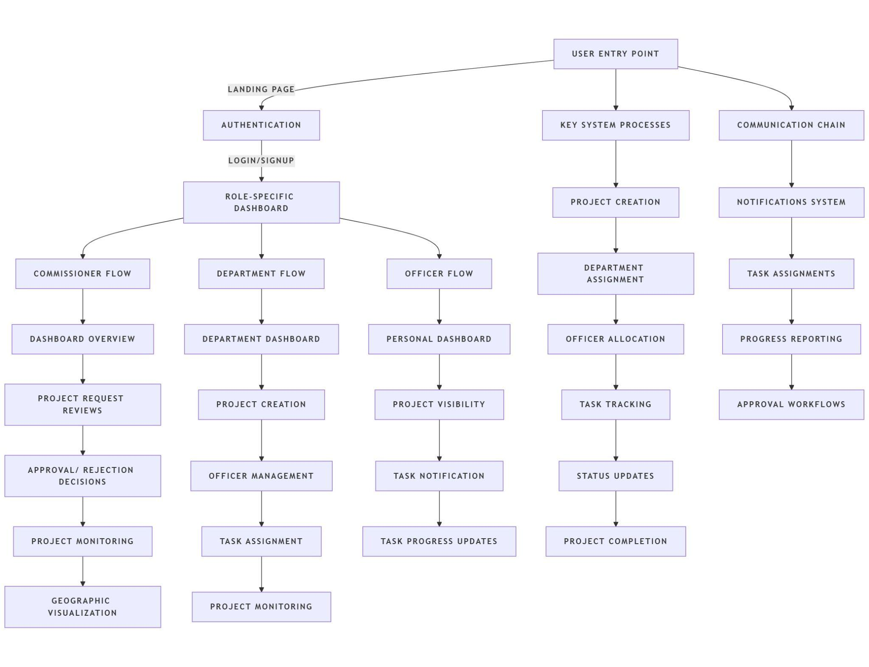

Fig. 5.2.1 PlanItUrban Platform - System Flow Diagram

Fig No 5.2.1 illustrates the system architecture and workflow of the PlanItUrban platform. It begins with the user entry point, leading to authentication and role-specific dashboards based on whether the user is a commissioner, department officer, or regular officer. Each role has a distinct flow: commissioners focus on project approvals and monitoring, departments handle project creation and officer management, and officers manage task updates. Simultaneously, core system processes like project creation, department assignment, communication chains, and notification systems operate to streamline coordination, enhance task tracking, automate approvals, and provide real-time status updates, ensuring efficient urban governance management.

**Algorithm**

**PlanItUrban Platform - System Flow Algorithm:**

The system workflow begins with the user entering the platform and undergoing authentication to determine their role—Commissioner, Department, or Officer. If the user is a Commissioner, they access a comprehensive dashboard to review project requests, approve or reject them, monitor ongoing projects, visualize data geographically, and manage key system processes including project creation, department and officer assignments, task tracking, communication, notifications, and progress reporting through automated workflows. If the user is part of a Department, they enter a department-specific dashboard to create projects, manage officers, assign tasks, and monitor projects. For an Officer, the flow provides access to a personal dashboard where they can view assigned projects, receive task notifications, and update task progress.

**Step 1:** Start

**Step 2:** User enters the platform (UserEntryPoint)

**Step 3:** Authenticate user credentials (Authentication)

**Step 4:** Identify UserRole (Commissioner / Department / Officer)

**If Commissioner:**

* Access Commissioner Dashboard
* Review and approve/reject project requests
* Monitor projects and visualize data geographically
* Manage project creation

**If Department:**

* Access Department Dashboard
* Create new projects
* Manage officers and assign tasks
* Monitor project progress

**If Officer:**

* Access Personal Dashboard
* View assigned projects, receive task notifications , update task progress in real-time

**Step 5:** End

## Chapter 6. Testing of the Proposed System

##### 6.1 Introduction to testing

Testing was a critical phase in ensuring the PlanItUrban platform functions reliably. Since the platform enables interdepartmental communication, project management, and conflict resolution, testing helped validate the correctness and robustness of core backend services.

##### 6.2 Types of tests Considered

We primarily conducted unit testing using Spring Boot's built-in testing framework. Key APIs related to user registration, project creation, conflict detection, and task updates were tested to ensure correct responses and data handling.

##### 6.3 Various test case scenarios considered

Section 6.3 presents the test case scenarios designed to validate key system functionalities. Table 6.3.1 summarizes the defined test cases and their results.

Table No. 6.3.1 Test Cases

| **Test Case ID** | **Scenario** | **Expected Output** | **Status** |
| --- | --- | --- | --- |
| TC_01 | Department registration API | Department created successfully | Passed |
| TC_02 | Officer project creation API | Project stored with accurate details | Passed |
| TC_03 | Conflict detection API | Conflict identified and notified | Passed |
| TC_04 | Task update API | Task progress updated correctly | Passed |

##### 6.4. Inference drawn from the test cases

The core APIs performed as expected during unit testing. The system correctly handled valid and invalid inputs, generated accurate responses, and managed edge cases without errors. Unit testing sufficiently validated the key backend functionalities essential for the smooth operation of the PlanItUrban platform.without system crashes.

## Chapter 7: Results and Discussion

##### Screenshots of User Interface (GUI)

The following screenshots depict the user interface (UI) of the PlanItUrban platform, showcasing its different pages and modules. These screenshots provide a visual overview of how users interact with the system based on their roles, highlighting key features, design aesthetics, and functionality.

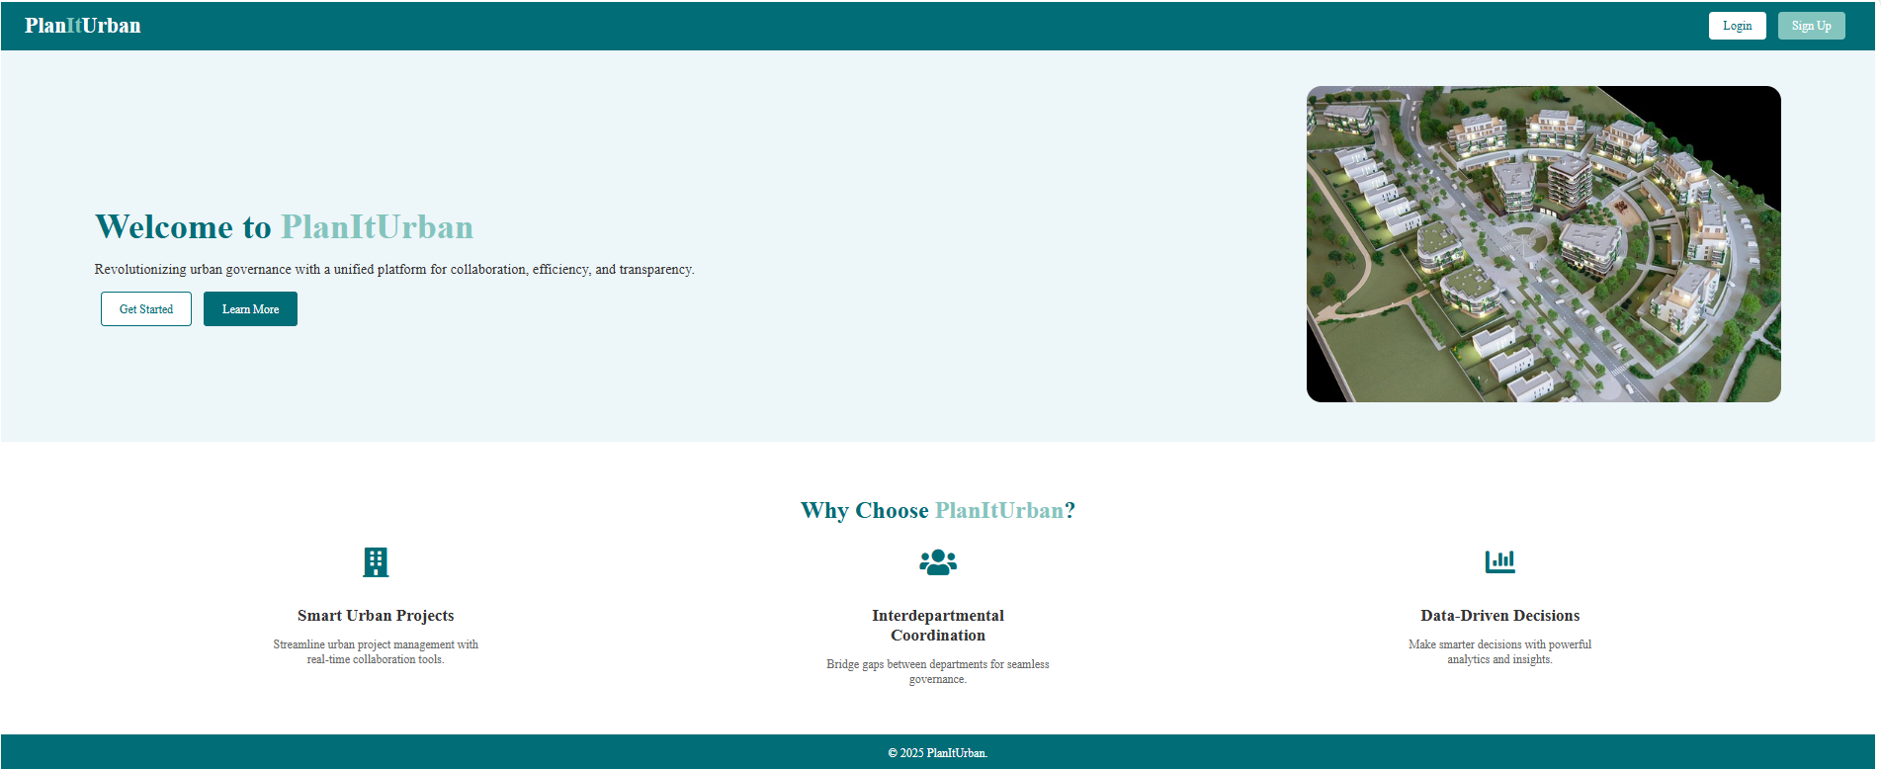

Fig. 7.1.1. Home Page

Fig 7.1.1. shows a teal-themed landing page for "PlanItUrban" platform with a welcome message highlighting urban governance with unified platforms. Features include a hero image of an aerial view of urban development, along with three value propositions: Smart Urban Projects, Interdepartmental Coordination, and Data-Driven Decisions.

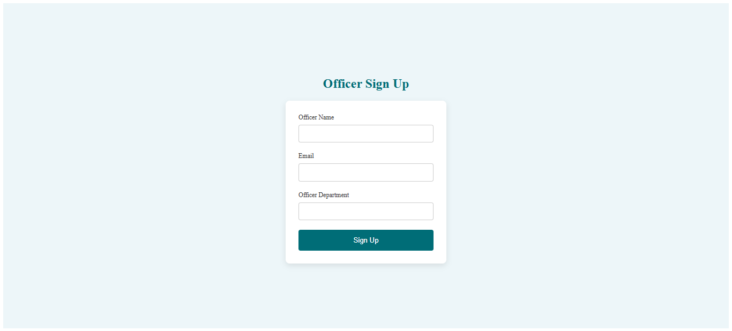

Fig. 7.1.2. Signup Page

The above Fig 7.1.2. shows a signup form specifically for officers with a light blue background. Contains fields for Officer Name, Email, and Officer Department, along with a teal "Sign Up" button at the bottom. The interface maintains the platform's clean, minimalist aesthetic.

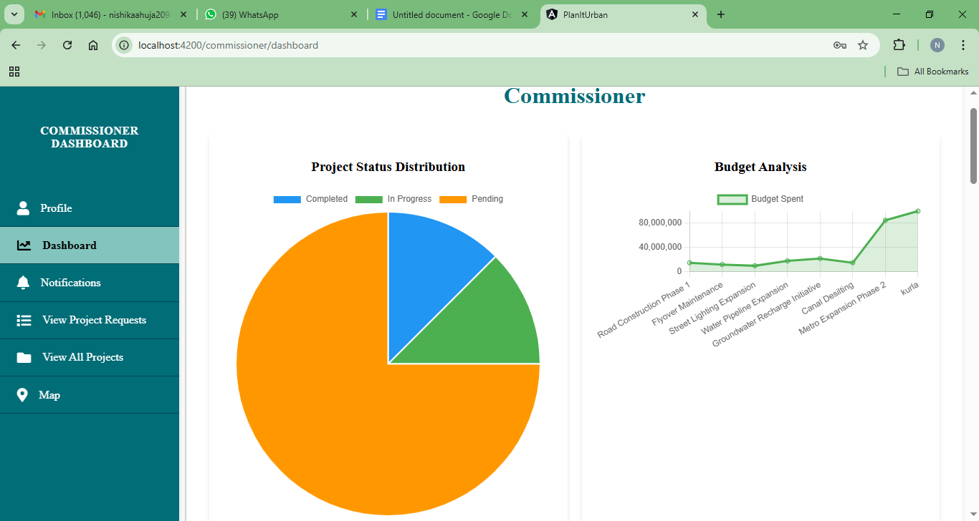

Fig. 7.1.3.1. Commissioner Dashboard Page

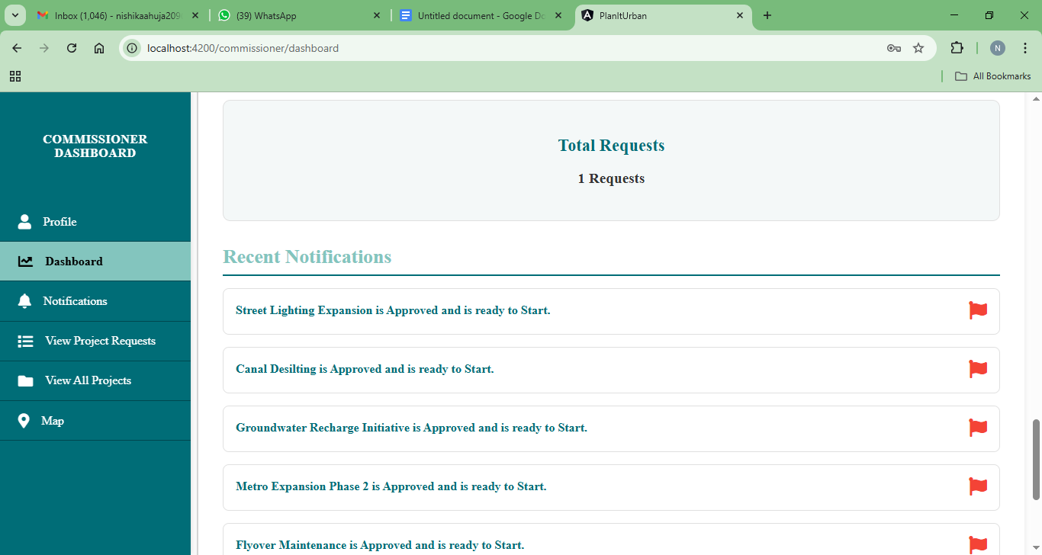

Fig. 7.1.3.2. Commissioner Dashboard Page

Above Figures Fig 7.1.3.1. and Fig 7.1.3.2. shows the Commissioner Dashboard showing a project status distribution pie chart with color-coded segments for Completed, In Progress, and Pending projects. Also displays a budget analysis line graph on the right. The left sidebar contains navigation options in the platform's teal color scheme.

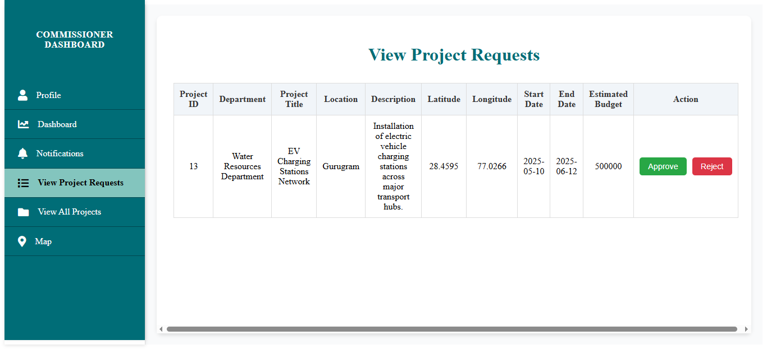

Fig. 7.1.4. View Project Requests Page

Fig 7.1.4. shows a continuation of the Commissioner Dashboard showing a list of pending projects, each with details including project name, purpose, location, start/end dates, and status. Two specific projects are shown: Street Lighting Expansion and Water Pipeline Expansion, both marked as "PENDING".

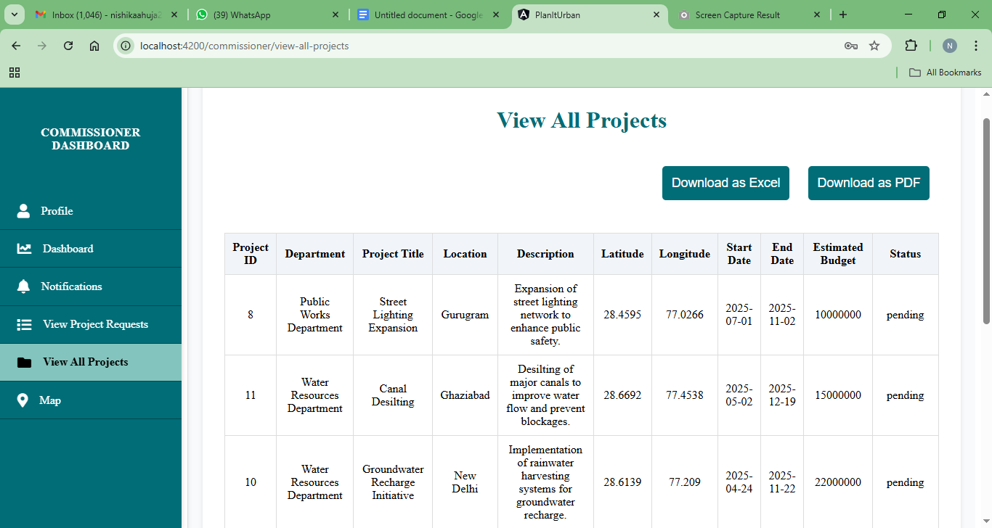

Fig. 7.1.5. View All Projects Page

Fig 7.1.5. shows a tabular view of project requests with detailed information columns including Project ID, Department, Project Title, Location, Description, Latitude, Longitude, Dates, Budget, and Action buttons. The interface includes approve/reject options for pending requests.

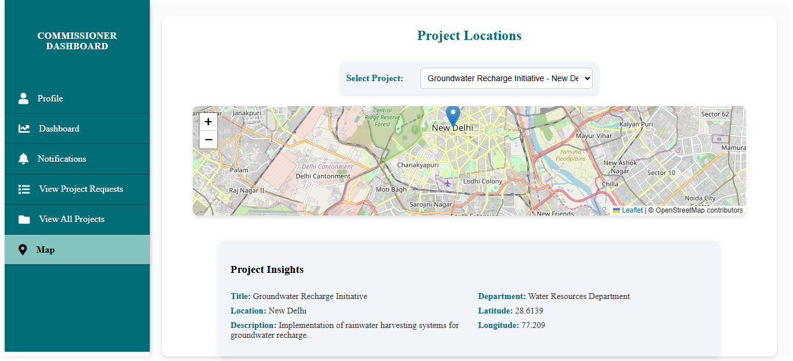

Fig. 7.1.6. Map Page

Fig 7.1.6. shows a geographical visualization of projects showing a map interface with the currently selected project "Groundwater Recharge Initiative" in New Delhi. Project insights are displayed below the map, showing details like department, location coordinates, and project description.

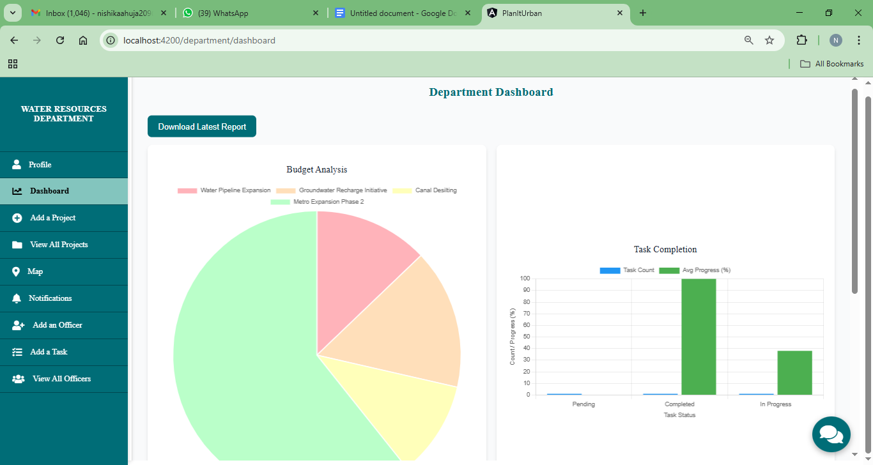

Fig. 7.1.7.1. Department Dashboard Page

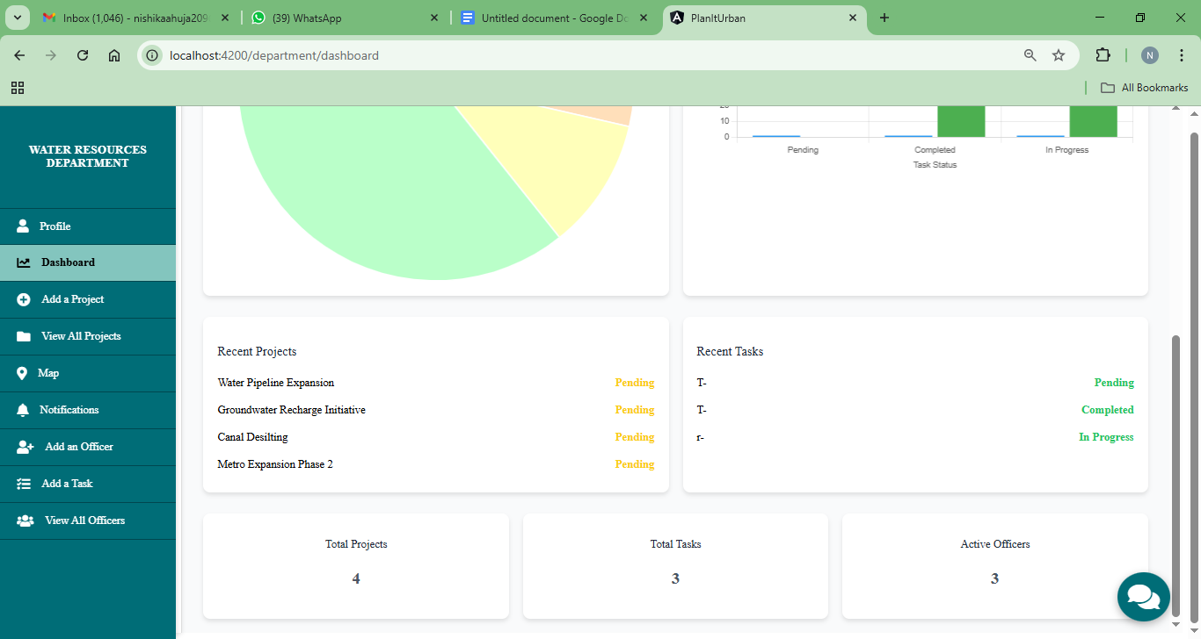

Fig. 7.1.7.2. Department Dashboard Page

Above Figures Fig 7.1.7.1 and Fig 7.1.7.2. shows the Water Resources Department dashboard featuring overview metrics of current projects and tasks. Displays cards showing pending projects, recent tasks, total projects count, total tasks count, and active officers count, along with a chatbot helper in the corner.

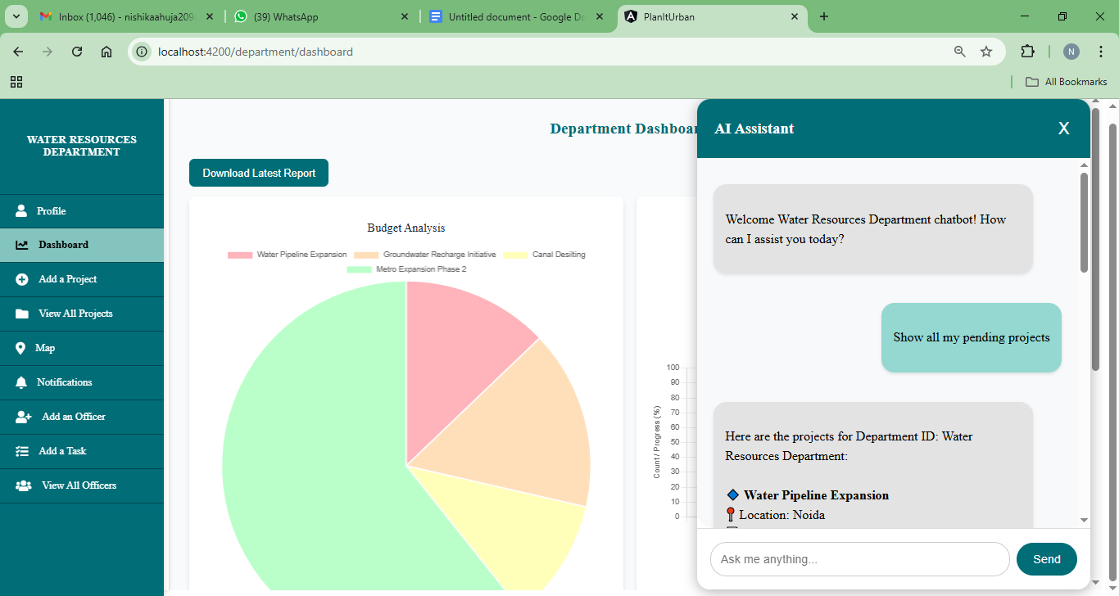

Fig. 7.1.8.1. Chatbot

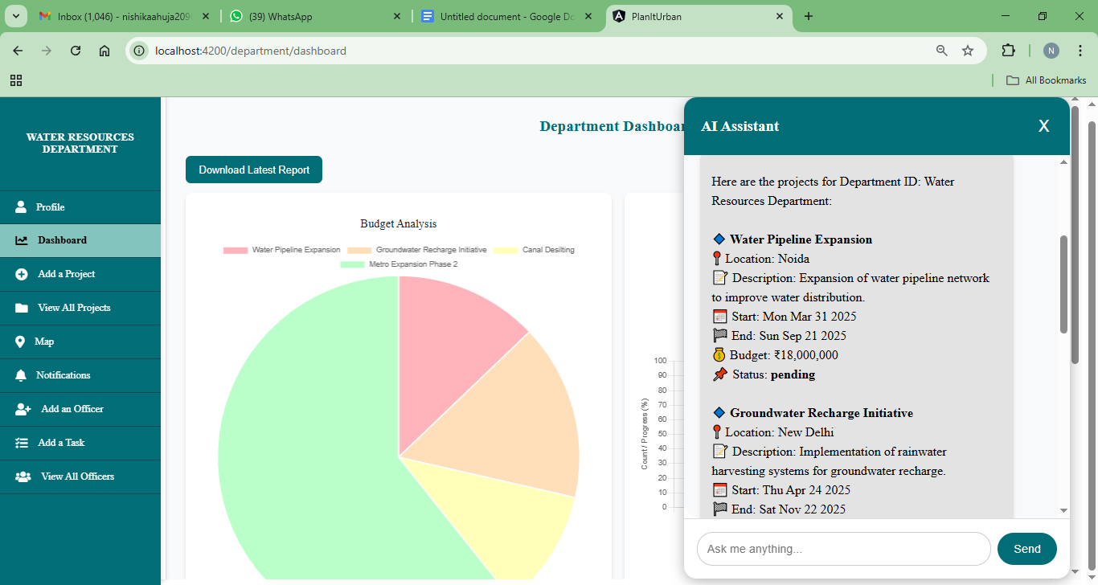

Fig. 7.1.8.2. Chatbot

Above Fig 7.1.8.1. and Fig 7.1.8.2. shows an AI assistant interface for the Water Resources Department with a conversation panel. The chatbot displays project information upon request, showing details of two department projects: Water Pipeline Expansion and Groundwater Recharge Initiative with their respective start dates, end dates, and budgets.

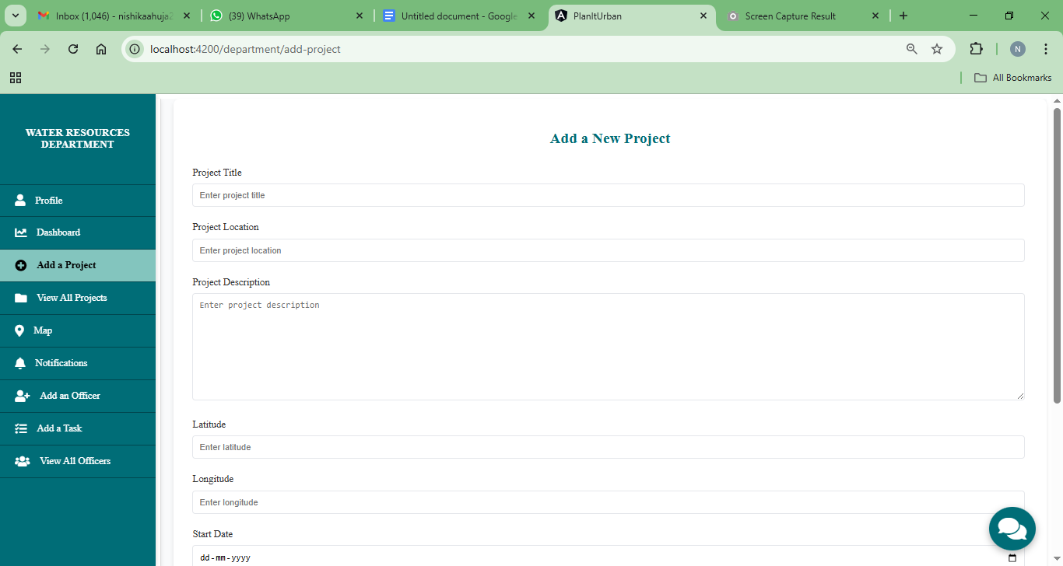

Fig. 7.1.9. Add a project Page

Fig 7.1.9. shows a form interface for adding new projects with fields for Project Title, Location, Description, Latitude, Longitude, and Start Date. The clean layout follows the department's teal color scheme with a sidebar navigation panel for accessing other functions.

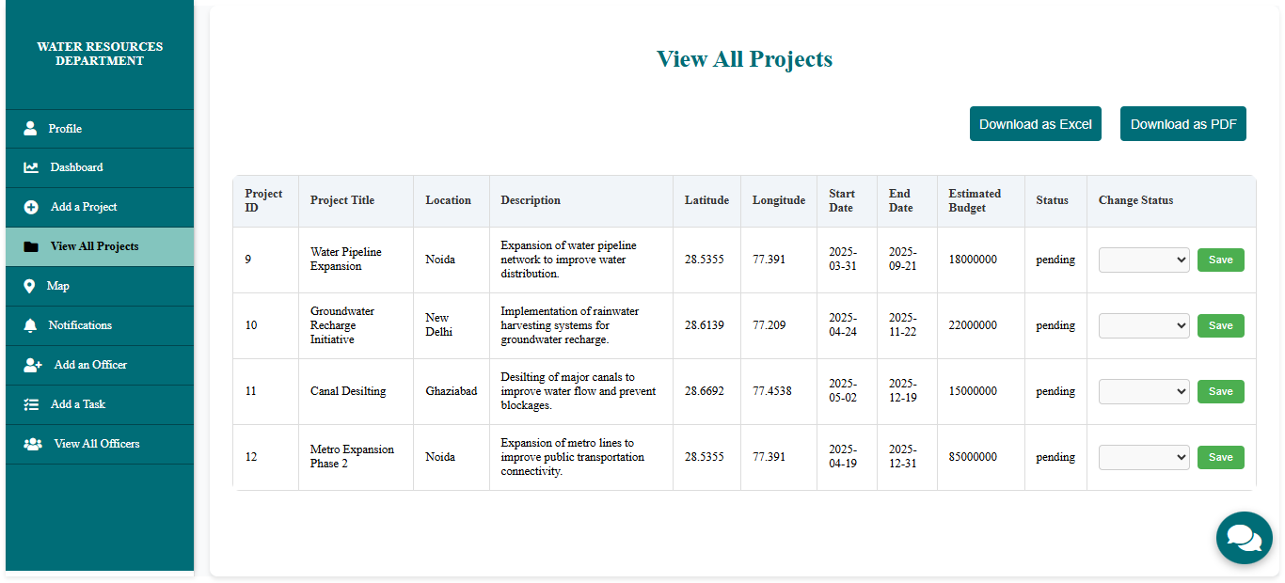

Fig. 7.1.10. View all projects Page

Fig 7.1.10. shows a comprehensive table showing all projects under the Water Resources Department with options to download as Excel or PDF. Projects displayed include Water Pipeline Expansion, Groundwater Recharge Initiative, Canal Dredging, and Metro Expansion, each with edit action buttons.

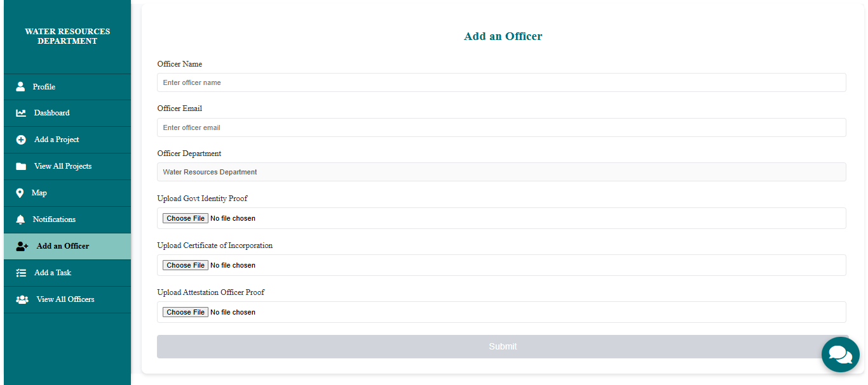

Fig. 7.1.11. Add a officer Page

Fig 7.1.11. shows a form for adding new officers to the department with fields for Officer Name, Email, Department (pre-filled as Water Resources Department), and multiple file upload sections for Officer ID, Certificate/Documents, and Additional Proof documents.

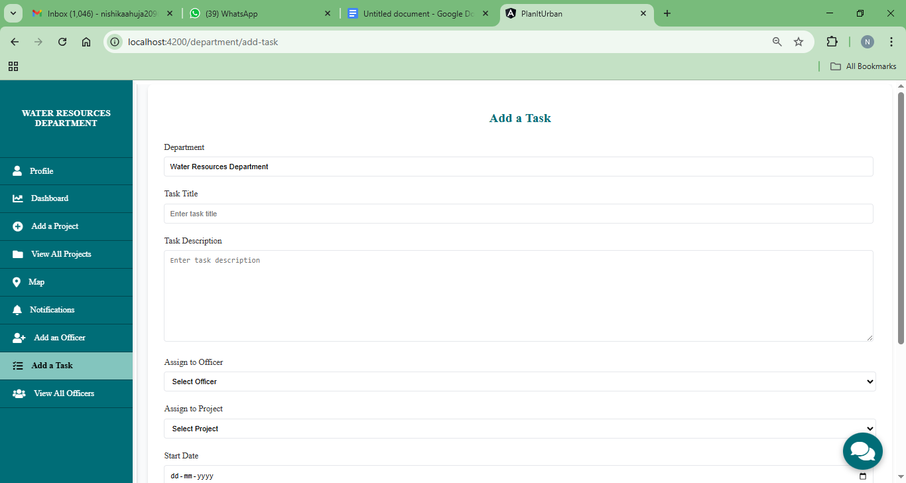

Fig. 7.1.12. Add a task Page

Fig 7.1.12. shows a task creation interface with fields for Department (pre-filled), Task Title, Description, Officer Assignment dropdown, Project Assignment dropdown, and Start Date. The form allows department managers to delegate specific responsibilities to officers.

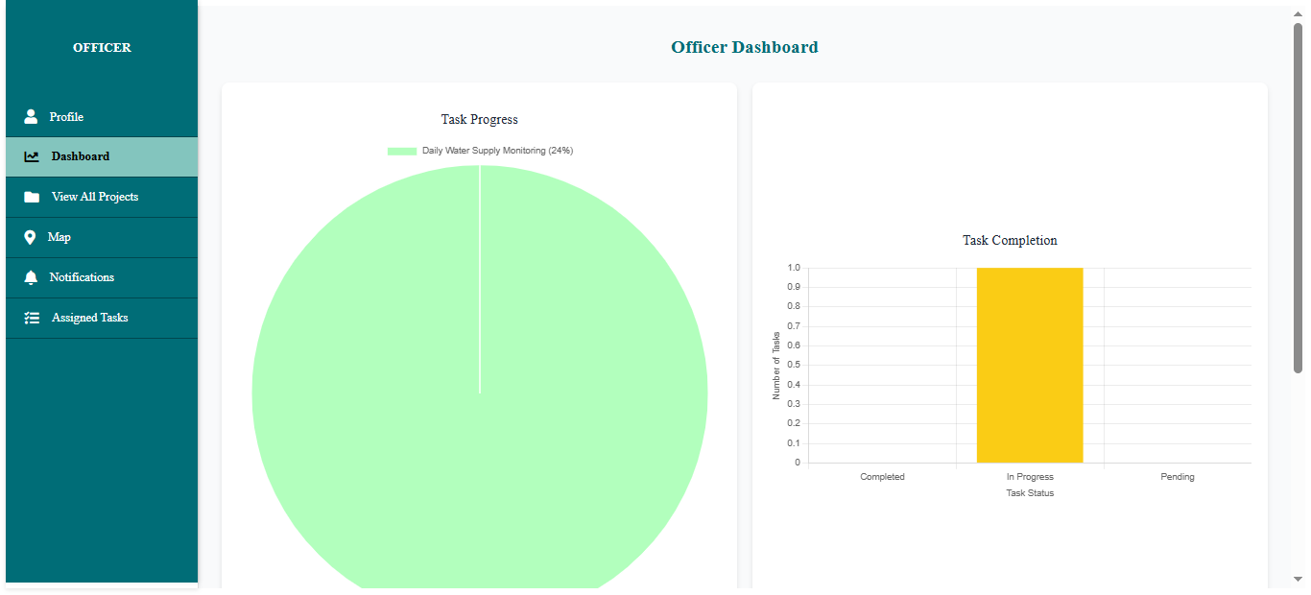

Fig. 7.1.13. Officer Dashboard Page

Fig 7.1.13. shows the Officer Dashboard shows task progress with a large pie chart predominantly in green indicating high completion rate, and a bar graph showing task completion statistics. The interface combines data visualization with a project list view below.

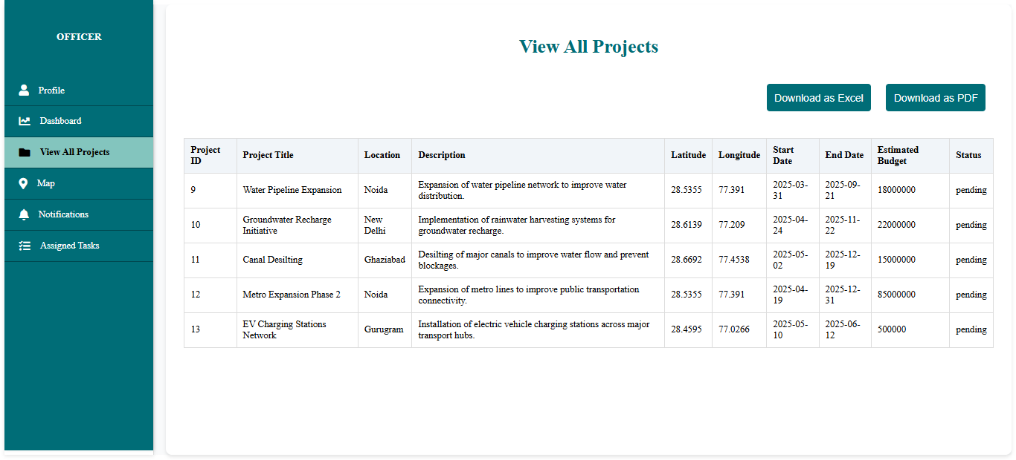

Fig. 7.1.14. View all projects Page

Fig 7.1.14. shows a project list view for officers showing all water-related projects they have visibility into. Each entry includes project title, location, description, coordinates, dates, budget, and status indicators, with a clean tabular layout for easy scanning.

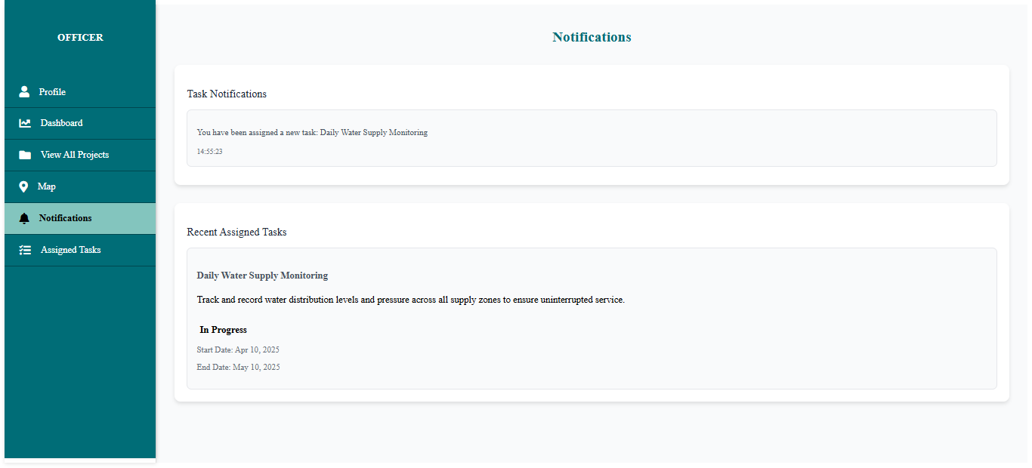

Fig. 7.1.15. Notifications Page

Fig 7.1.15. shows a notification center for officers showing task notifications and recent assigned tasks. The interface displays details about water supply monitoring tasks including status indicators, due dates, and priority levels to help officers track their responsibilities.

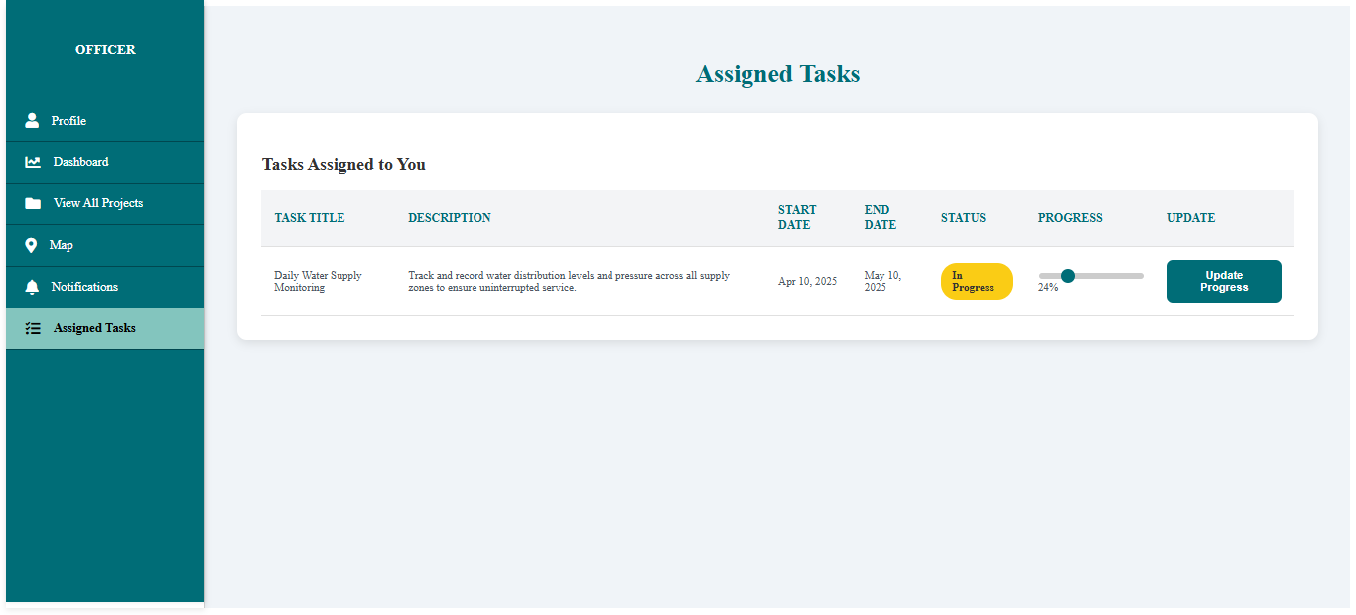

Fig. 7.1.16. Assigned tasks Page

Fig 7.1.16. shows a comprehensive view of tasks assigned to the officer with details including task title, description, start/end dates, status (shown as "In Progress"), a visual progress bar, and an update button. Designed for tracking individual workload and progress.

##### Performance Evaluation measures

* **Budget Efficiency Score:** Measures whether the estimated budget aligns with impact and duration.  
  Formula: (Estimated Budget / Project Duration) normalized
* **Timeliness Index:** Evaluates how soon a project will begin and how long it will take.  
   Formula: Inverse of Start Date Delay + Inverse of Duration
* **Geographic Priority:** Gives priority to rural/underserved areas using proj_location and coordinates.
* **Project Readiness Score:** Based on project status (Planned, In Progress) and approval status (isApproved field).
* **Strategic Importance Score:** Scores based on alignment with key sectors (e.g., Education, Health, Transport)

##### Input Parameters / Features considered

* **proj_title, proj_desc**
* **proj_location, proj_latitude, proj_longitude**
* **proj_start_date, proj_end_date (used to calculate duration)**
* **proj_estimated_budget**
* **proj_status**
* **isApproved (if used by the system)**
* **dept_id (could be used to weigh based on departments)**

##### 7.4 Inference drawn

Based on the recommendation engine, departments such as Healthcare, Urban Development, and Agriculture emerge as top priorities, provided they align with the key metrics identified in the engine, such as:

* High impact sectors (Healthcare, Urban Development, Agriculture)
* Timely start and long duration coverage
* Budget allocations that align well with the scope
* Strategic geographic targeting (rural, metropolitan, underserved regions)

However, the prioritization and characteristics may vary depending on the actual data points available. Different departments may rank higher or lower based on specific budgetary constraints, geographic targeting, or sector importance that could be more relevant in certain contexts or datasets.

## Conclusion

##### 8.1 Limitations

Despite the advanced capabilities of the PlanItUrban platform, certain limitations could impact its performance and scalability. The system’s effectiveness is highly dependent on the accuracy and consistency of departmental data; outdated or incomplete information can lead to flawed decision-making. Additionally, while project locations are mapped using coordinates, the platform may struggle to detect overlaps accurately in densely populated or informally developed areas due to limited spatial awareness. Real-time communication between departments, though streamlined, relies on server-side triggers and scheduled tasks, which could introduce minor delays during periods of high activity. Furthermore, as the number of departments and projects grows, database load and response times could suffer unless backend infrastructure is carefully optimized to support scalability.

**8.2** **Conclusion**

##### PlanItUrban offers a robust and centralized solution for enhancing coordination in urban governance by streamlining communication, project management. The platform significantly improves operational efficiency, reduces project overlaps and delays, and fosters data-driven decision-making. It also promotes greater transparency and accountability among agencies, strengthening trust and collaboration. With the integration of key modules like alert notifications, and dashboard analytics, PlanItUrban supports more effective planning and interdepartmental collaboration, ultimately contributing to the creation of smarter, more well-coordinated cities.

##### 8.3 Future Scope

Despite the success of PlanItUrban, several future enhancements can address its limitations:

* **Data Accuracy:** Integration of automated data validation and government database syncing can ensure consistent and up-to-date departmental information.
* **Spatial Awareness:** Incorporating GIS and AI-based spatial analysis will improve overlap detection in densely populated or informal areas.
* **Real-Time Communication:** Transitioning to event-driven communication (e.g., WebSockets) can reduce delays during high-traffic periods.
* **Scalability:** Adopting a microservices architecture with load balancing and database sharding will improve performance as the system scales.

These improvements will further enhance PlanItUrban’s capabilities, making it more reliable, efficient, and scalable.

**REFERENCES**

| [1] | [Z.-R. Peng, K.-F. Lu, Y. Liu, and W. Zhai, "The Pathway of Urban Planning AI: From Planning Support to Plan-Making," Journal of Planning Education and Research, vol. [Volume Number], Jun. 2023.](https://www.researchgate.net/publication/371846171_The_Pathway_of_Urban_Planning_AI_From_Planning_Support_to_Plan-Making) |
| --- | --- |
| [2] | [S. Steiniger, M. E. Poorazizi, and A. J. S. Hunter, "Planning with Citizens: Implementation of an e-Planning Platform and Analysis of Research Needs," Urban Planning, vol. 1, no. 2, pp. 49-64, Jun. 2016](https://www.cogitatiopress.com/urbanplanning/article/view/607/373) |
| [3] | [P. Repette, J. Sabatini-Marques, T. Yigitcanlar, D. Sell, E. Costa, Land, vol. 10, no. 1, p. 33, Jan. 2021](https://www.mdpi.com/2073-445X/10/1/33) |
| [4] | [Shrivastav, S. (2017). Urbane: Community Driven Architecture and Planning Through a Mobile Social Platform. In: Vinod Kumar, T. (eds) E-Democracy for Smart Cities. Advances in 21st Century Human Settlements. Springer, Singapore.](https://link.springer.com/chapter/10.1007/978-981-10-4035-1_16) |
| [5] | [D. Kylasam Iyer and F. Kuriakose, "Digital Platforms as (Dis)Enablers of Urban Co‐Production: Evidence From Bengaluru, India," Co‐Production in the Urban Setting: Fostering Definitional and Conceptual Clarity Through Comparative Research Mar. 2024.](https://www.cogitatiopress.com/urbanplanning/article/view/7262/3639) |
| [6] | [A. Patel, "Preventing COVID-19 Amid Public Health and Urban Planning Failures in Slums of Indian Cities," World Medical & Health Policy, Jul. 14, 2020.](https://onlinelibrary.wiley.com/doi/abs/10.1002/wmh3.351) |
| [7] | [A. Anthony, "The Role of Community Engagement in Urban Innovation Towards the Co-Creation of Smart Sustainable Cities," J. Knowl. Econ., vol. 15, pp. 1592–1624, Mar. 2024.](https://link.springer.com/article/10.1007/s13132-023-01176-1) |
| [8] | [T. Yigitcanlar, N. Kankanamge, M. Regona, A. R. Maldonado, B. Rowan, A. Ryu, K. C. Desouza, J. M. Corchado, R. Mehmood, and R. Y. M. Li, "Artificial Intelligence Technologies and Related Urban Planning and Development Concepts: How Are They Perceived and Utilized in Australia?," School of Built Environment, Queensland University of Technology, Brisbane, Australia, Nov. 2020.](https://www.researchgate.net/publication/346951804_Artificial_Intelligence_Technologies_and_Related_Urban_Planning_and_Development_Concepts_How_Are_They_Perceived_and_Utilized_in_Australia) |
| [9] | [M. Schmelzle, S. Wenzel, J. Meurer, T. Ludwig, and V. Pipek, "Digital Urban Planning Platforms: The Interplay of Digital and Local Embeddedness in Urban Planning," Proc. ACM on Hum.-Comput, July 2021.](https://www.researchgate.net/publication/352882970_Digital_Urban_Planning_Platforms_The_Interplay_of_Digital_and_Local_Embeddedness_in_Urban_Planning) |
| [10] | [P. Chamoso, A. González-Briones, F. De La Prieta, G. K. Venyagamoorthy, and J. M. Corchado, "Smart city as a distributed platform: Toward a system for citizen-oriented management," *Comput. Commun.*, vol. 155, pp. 290-300, Jan. 2020](https://www.sciencedirect.com/science/article/abs/pii/S0140366419321152#preview-section-snippets). |
| [11] | [A. J. Y. Goh, W. C. R. Goh, and C. H. Goh, "Smart City 4.0 from the Perspective of Open Innovation," Jan. 2020.](https://www.researchgate.net/publication/337383870_Smart_City_40_from_the_Perspective_of_Open_Innovation) |
| [12] | [T. H. Son, Z. Weedon, T. Yigitcanlar, T. Sanchez, J. M. Corchado, and R. Mehmood, "Algorithmic urban planning for smart and sustainable development: Systematic review of the literature," Sustainable Cities and Society, vol. 94, 104562, Mar. 2023.](https://www.sciencedirect.com/science/article/pii/S2210670723001737) |
| [13] | [P. Repette, J. Sabatini-Marques, T. Yigitcanlar, D. Sell, and E. Costa, "The Evolution of City-as-a-Platform: Smart Urban Development Governance with Collective Knowledge-Based Platform Urbanism," Land, vol. 10, no. 1, p. 33, Jan. 2021.](https://landportal.org/library/resources/103390land10010033/evolution-city-platform-smart-urban-development-governance) |
| [14] | [Fabusuyi, T., & Johnson, M. P. (2022). Enhancing the quality and social impacts of urban planning through community-engaged operations research.](https://journals.sagepub.com/doi/full/10.1177/23998083211054851)  [Environment and Planning B: Urban Analytics and City Science.](https://journals.sagepub.com/doi/full/10.1177/23998083211054851) |
| [15] | [Afzalan, N., T. W. Sanchez, and J. Evans-Cowley. 2017. “Creating smarter cities: Considerations for selecting online participatory tools.” Cities 67: 21–30.](https://www.sciencedirect.com/science/article/abs/pii/S0264275116306412) |
| [16] | B. D. Koch and M. J. Skurla, "Smart city infrastructure coordination platform," U.S. Patent US 10,354,129 B2, issued Jul. 16, 2019. |
| [17] | S. A. Mize and J. M. Voss, "Real-time municipal project tracker," U.S. Patent US 10,572,834 B1, issued Feb. 25, 2020. |
| [18] | G. Nadkarni, I. B. Madhukar, H. Tewari, E. M. Barretto, P. P. M. Nair, R. Sinha, S. S. S. Kumar, R. Nand, and V. S., "Method and system for managing one or more processes in an organization," Indian Patent Application IN201921012345, filed 2019. |

**Urban Governance Optimization: A Web-Based Solution for Enhanced Coordination and Sustainable Development**

| *Indu Dokare*  *Department of Computer Engineering*  *Vivekanand Education Society’s*  *Institute of Technology Chembur*  *Mumbai 400074* | *Gayatri Wadhwani*  *Department of Computer Engineering*  *Vivekanand Education Society’s*  *Institute of Technology Chembur*  *Mumbai 400074* | *Nishika Ahuja*  *Department of Computer Engineering*  *Vivekanand Education Society’s*  *Institute of Technology Chembur*  *Mumbai 400074* |
| --- | --- | --- |

| *Simran Gurdasani*  *Department of Computer Engineering*  *Vivekanand Education Society’s*  *Institute of Technology Chembur*  *Mumbai 400074* | *Hainy Chughria*  *Department of Computer Engineering*  *Vivekanand Education Society’s*  *Institute of Technology Chembur*  *Mumbai 400074* |
| --- | --- |

| **Abstract— Challenges with urban administration are poor communication and project delays, which often lead to inefficiencies that hinder infrastructure growth and sustainable development. Our project is an online urban project management system designed to enhance real-time decision-making, and enhance interdepartmental communication. The platform ensures successful project implementation, compliance with sustainability, and more effective urban infrastructure planning through conflict resolution automation, administrative operation optimization, and the incorporation of predictive modeling.**  **The technology further enables data-informed decision-making, active participation of citizens for better accountability, and openness in** | **governance. This research explores the role of structured governance in urban growth, addressing critical inefficiencies through an integrated, scalable method that allows for operational efficacy and long-term sustainability.**  **Keywords— Urban governance, interdepartmental collaboration, project management, sustainable development.**   1. Introduction   Based on city reports [12], poor planning and project delays have been caused by the growing governance complexity due to the rapid urban population growth. Many municipal organizations are plagued by fragmented management systems, whereby |
| --- | --- |

| each department operates in isolation, leading to duplicated projects and wasteful expenditure.It takes projects 50% longer to finish and more than 30% above their total cost [5].  Through the use of centralized planning platforms, cities across the globe are shifting towards organized governance systems and enhancing project efficiency [12].Governments utilizing these platforms indicate enhanced reduced project delays, and more transparent decision-making. Yet, the absence of a single system for intelligent conflict resolution, real-time monitoring, and communication in existing systems results in continued inefficiencies [9].  Lack of integrated digital solutions, and poor communication are some of the most significant urban governance problems. The main governance problems that affect project implementation and the development of cities are summarized diagrammatically below:    Fig.1. Urban Governance Challenges  Numerous case studies [22] have shown bureaucratic inefficiencies, departmental lack of coordination, and the absence of a central decision-making framework as some of the problems facing urban governance. Fragmented governance structures result in additional project delays, cost overruns, and lower citizen satisfaction, research has found. To support governance audits, the most salient concerns involve flawed systems for the involvement of citizens, | poor transparency in budget matters, and absence of urban planning departmental coordination [17].There should be a coherent data-based procedure encouraging collaboration coupled with ensuring administration branch accountability for tackling these matters.  Urban projects typically suffer from hidden delays in cases where there is no real-time monitoring, such that the progress milestones become lopsided. Project execution and planning are significantly improved with strong governance frameworks, including automated conflict of interest management and forecasting solutions.  We can ascertain pivotal domains wherein structured digital solutions engender significant change by comprehending these matters [21].Our proposal is a start-to-finish city project management system enabling real-time monitoring of urban initiatives, and enhanced interdepartmental cooperation. Its auto-resolution of conflict, formalized work assignment, and sustainability monitoring, compared with conventional governance structures, enhance the efficiency and openness of city growth.   1. Existing Works   Various researches have focused on maximizing urban governance through the use of technology to improve planning and implementation.  1. Urban governance models: Although most models of governance are policy-oriented in their administration, their implementation is ineffective because they are not digitally adaptable [4].  2. Digital twins & smart cities: With the implementation of IoT sensors and digital |
| --- | --- |

| twins, monitoring and predictive analytics have increased, helping governments make highly informed decisions [5].  Urban ventures continue to miss coordinated operations with these improvements. By unifying essential components of governance onto a single planning and execution platform, our process fills these voids [9].  The following pie chart provides an overview of the relative importance of the key governance factors and how they contribute to planned urban development.  Chart  **Fig 2. Distribution of research methodologies in urban planning Studies.**  The pie chart indicates the relative focus on governance areas like artificial intelligence (AI) in infrastructure development, urban planning, and citizen participation. AI-based governance systems greatly minimize bureaucratic inefficiencies and enhance decision-making effectiveness by 40% [23].Project failure rate is minimized through the data-driven governance, which promotes efficient budget allocation management, schedule prediction, and project authorization [20].  The pie chart further represents the desire of citizens for their participation in government. Top-down government-structured projects are 25% less likely to be successful as compared to city projects involving participatory citizens [26].  Transparency of the project and improved | public confidence have been evidenced through digital mechanisms with the scope to receive immediate community feedback and participation in the budget [14]. Lastly, the graph illustrates the significance of infrastructure and digital twins in contemporary urban planning. According to studies, cities with digital twin models can save up to 30% in operating costs and boost 20% sustainability compliance [16]. Urban planners can improve long-term sustainability goals, optimize land use, and simulate environmental impacts by incorporating AI-based models [21].   1. Proposed Statement   Shortage of structured project management, scattered interdepartmental coordination are key issues for the city government in the current city. Government departments function autonomously, leading to disorientation, duplicated projects, and wastage. Decision making is being made difficult to be accelerated without a consolidated platform to monitor the approvals of the project, schedule of works, and funds. Lack of coordination among departments, as research shows, results in up to 50% delay in projects, escalating costs, and reducing overall urban efficiency. Development priorities and bottlenecks in infrastructure arise due to departments' failure to identify and resolve issues beforehand because they lack real-time monitoring systems.  Besides, traditional models of governance are largely reliant on manual intervention, which exposes them to inaccuracies, inefficiencies, and delays. It takes a long time to make decisions because of bureaucratic red tape, resulting in overfunding or underfunding of key urban projects. Lack of predictive analysis and automated workflow management exacerbates such inefficiencies to the point |
| --- | --- |

| of making it impossible for city governments to anticipate problems and act upon data-driven remedies. Moreover, current governance mechanisms lack a geospatial visualization tool to track projects in more than one place, preventing the authorities from making proper analyses of urban development trends. As such, urban infrastructure projects are plagued by bad planning, mismanagement, and failure to adopt long-term goals of sustainability.  In view of addressing urban administration inefficiencies, our research suggests a centrally managed urban project management system that consolidates numerous departments under the same umbrella. The technology supports coordination across departments, ensures automation of project approval, and allows real-time monitoring of under-progress developments. It shuns duplication efforts, eliminates repetition of projects, and supports decisions based on information. The platform facilitates collaboration among commissioners, departments, and officers through an open, interactive platform.  The commissioner's role as a governing body is supplemented by an effective mechanism for monitoring projects. The software creates a dynamic dashboard of all current, completed, and pending projects department-wise in real time. Commissioners approve or reject project proposals based on feasibility, priority, and availability of funds. A geospatial visualization option also helps them identify project locations and overlapping projects, enabling them to ensure planned urban development. This is accomplished through departmental project assignment and financial expenditures review, allowing the commissioner to avoid unnecessary delays. The system also has automated conflict detection, recognizing possible scheduling and project conflicts as well as allowing | commissioners to reschedule project deployment as needed.  At the departmental level, there is efficient and concerted city project management. Departments can formulate proposals for projects with major parameters like location, finance, and anticipated timelines. On approval of the projects, they are brought into the implementation stage, where the officials are assigned a particular role. Budgeting through the platform ensures that financial expenditures are allocated properly and there are no misappropriations and over-spending. An easy-to-use dashboard interface enables departments to track their current projects, evaluate progress, and accordingly adjust it. Monitoring task performance is also a part of the system, through which departmental heads can track officer contributions and ensure timely compliance with deadlines.  Officers are responsible for executing assigned tasks and submitting current reports on their progress. The system facilitates organized delegation of tasks, whereby officers are assigned tasks with specified dates and priority levels. The program offers real-time status reports, making it possible for supervisors to track task completion rates and act when delays are experienced. Officers also receive automatic reminders on assignments, status changes, and important deadlines. To enhance productivity, the platform features a task progress visualization tool that enables departments to find bottlenecks and streamline execution processes. The strategy ensures that all officers are accountable for their roles, minimizing inefficiencies in urban project implementation.  One of the most unique features of the platform is its artificial intelligence-powered chatbot. The chatbot, developed using the Gemini-1.5-Flash API, |
| --- | --- |

| enables department heads to obtain information regarding project status, budget, and deadline in real-time using SQL-based queries. This reduces a lot of time for information retrieval and enables decision-making at a much quicker rate. The chatbot also facilitates citizens with queries on general governance, making navigation through the system easier. The proposed methodology improves city planning by guaranteeing a systematic workflow, auto-reminders, dispute settlement, and data-based governance, hence resulting in effective, transparent, and well-organized city development.   1. Methodology   The proposed system is developed in a modular fashion to enable efficient project management, real-time monitoring, and systematic task execution. Every module has a specific role to play in ensuring efficient interdepartmental coordination. The system consists of six basic modules: user management, project management, task assignment, conflict management, notification system, and support by chatbot.  **User Management Module:** This module is responsible for authentication, role-based access control, and data protection. It ensures that only approved users (commissioners, department heads, and officers) can access the system. New officials can be registered and authenticated, and the appropriate rights are assigned depending on their roles. Critical project data is secured and unauthorized access is avoided by using role-based access control (RBAC). Two-factor authentication (2FA) is employed to enhance security to avoid unauthorized alteration of project records.  **Project Management Module:** The Project Management Module enables departments to submit, track, and manage projects in a | more efficient way. Each project submission contains complete details such as the title of the project, location, budget, departmental ownership, and estimated date of completion. After a proposal is submitted, it goes through a commissioner review process to determine feasibility before it is approved. Approved projects are subsequently assigned to particular departments for implementation. This module also gives duplication detection techniques to prevent duplicate project proposals. This module also includes a budgeting system for monitoring financial allocations so that they are maximized and not overspent.  **Task Allocation Module:** Task Allocation Module has the duty of breaking down sanctioned projects into smaller, manageable tasks and allocating them to officers. Task priority and deadline can be set by departments to enable workflows to run seamlessly. Officers are alerted upon task allocation and can see the status in real-time via the system's task tracking interface. This module also produces job performance reports, which allow department managers to track efficiency and eliminate any delay before it occurs. This module contains task dependency mapping, which ensures that subsequent tasks are executed in the correct order without derailing project schedules.  **Conflict Resolution Module:** The Module for Conflict Resolution identifies overlaps in projects, schedule challenges. It uses geospatial analysis to identify projects in the same location and determines potential conflicts. When two projects require the same time frame, it alerts the commissioner, who can then reorder project implementation. A priority score algorithm helps ensure high-priority projects are addressed first, minimizing infrastructure overlap. The system also has a historical conflict analysis component, which assists |
| --- | --- |

| planners in not repeating past project scheduling mistakes.  **Notification System Module:** This module supports real-time communication among stakeholders, sending out automatic alerts for project approvals, task assignments, deadline reminders, and budget updates. Officers receive high-priority alerts whenever they are assigned new duties, while department leaders are alerted when there are project status changes. Commissioners are notified of schedule conflicts and budget discrepancies as high-priority. The notification system uses email to ensure that all critical updates are forwarded to their respective receivers in the shortest time possible.  **Chatbot Assistance Module:** The Chatbot Help Module is a computer AI-based virtual assistant that helps departments and officers fetch project-related information efficiently. The chatbot, implemented with the help of the Gemini-1.5-Flash API, answers queries from users and retrieves live information from the system database. When an officer asks the status of a project, the budget for it, the chatbot runs SQL queries and displays the needed information. The chatbot also responds to general governance queries, giving immediate responses without the need for manual database lookup. The app also has a Download Latest Report feature, which allows departments to generate PDF reports of project status, critical bottlenecks, and potential solutions.  By having a systematic process for the approval of projects and delegation of work, the system ensures effective communication and coordination among commissioners, departments, and officials. Each project has a predetermined lifespan beginning with a department presenting a proposal, which is then reviewed by the commissioner. After approval, officials are assigned responsibilities and maintain the system | informed regarding their progress so that department leadership can monitor execution in real-time. Through ensuring that each stakeholder recognizes their role and can track advancement without relying on manual reporting, this systematic methodology minimizes delays and misunderstandings.  The system adopts rigorous role-based access control to guarantee changes being made at various project phases by the authorized users only, keeping accuracy and consistency in project implementation. While departments see to project submission and officer allocation, commissioners use maximum power and deal with project approvals as well as conflicts. To provide for a hierarchy of responsibilities to always be clearly established, officers may only alter the status of tasks assigned to them. This keeps all decisions regarding the project in writing and traceable, eliminates unauthorized alterations, and provides data integrity.  On top of this, the system contains automated progress monitoring, allowing the department heads and commissioners to track the project at each stage. The task status has to be updated periodically by the officers once a project has been vetted and duties have been distributed, ensuring each step is consistently documented. Increased oversight is provided through the use of the dashboard's real-time graphical indicators displaying completed, active, and pending work. This keeps each department on pace toward the project's overall goal of development through less chance of misunderstanding and unnecessary delay. The method increases responsibility and ensures the projects completion by deadlines by demanding real-time status submissions.Apart from that, the system also gives complete progress reports that allow stakeholders to follow performance patterns and identify potential bottlenecks. |
| --- | --- |

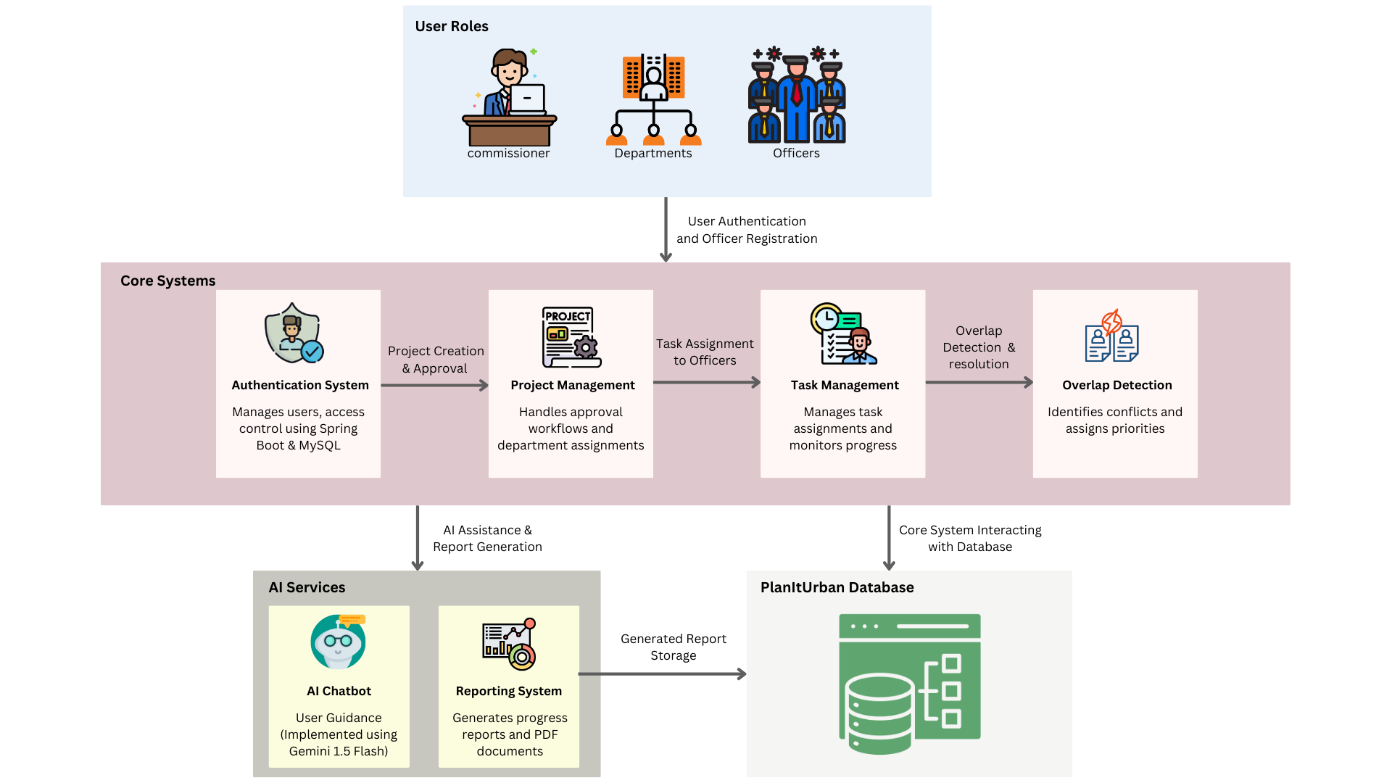

**Fig.3. System Architecture Diagram**

| The diagram illustrates the system architecture, namely the interaction between user roles, core systems, AI services, and the database. The system combines project management, work allocation, conflict resolution, and AI-based reporting to streamline urban planning. The architecture consists of the following main components:  **1**. **User Roles:**  There are three main user roles that access the system.   * Commissioner: Manages project approvals and resolves conflicts. * Departments: Multiple urban planning departments participate in the implementation of projects. * Officers: They have specific project implementation assignments.   Such users are authenticated before using the system to achieve role-based protection.  **2. Core Systems.**  The core functional elements of the system are authentication, project management, task tracking, and overlap detection. | * Authentication System: The authentication system is implemented based on Spring Boot and MySQL to provide secure user login as well as access control. It verifies the credentials of commissioners, department officials, and officers prior to providing entry. * Project Management: Oversees project initiation, approval procedures, and departmental task allocation. This facilitates projects to align with urban development goals and departmental mandates. * Task management: It facilitates easier task delegation to officers, monitoring of progress, and confirmation that assigned tasks are done on time. * Overlap Detection: Identifies rival projects by scanning spatial and temporal overlaps. It ranks projects according to their urgency, and commissioner choices, to prevent repetitive work.   All these systems possess a standardized process of work in which the transition from |
| --- | --- |

| project approval to task completion is ensured.  **3. AI Services:**  The system utilizes AI features for support and report generation.   * AI Chatbot: Developed with Gemini 1.5 Flash, the chatbot provides real-time user support to officers and departments for faster navigation of the system. * Reporting System: Automatically produces PDFs and progress reports so that stakeholders can view project status, approvals, and performance measures.   These AI services enhance system usability by removing the need for manual intervention as well as making processes more efficient.  **4. Database:**   * The system has its core nucleus as the master database that holds project data, assignment of tasks, user authentication, and reports generated. * It provides integration of core systems with AI services, and data consistency and real-time availability are provided**.**  Seamless Process Execution and Data Flow: The system follows a structured workflow to ensure smooth execution, from user authentication to project completion. Each component interacts efficiently to maintain data integrity and optimize task management.   1. **User Authentication & Officer Registration**: Users log in via the authentication system. 2. **Project Creation & Approval**: Approved projects are assigned to relevant departments. | 1. **Task Assignment to Officers**: Officers receive tasks and update progress. 2. **Overlap Detection & Resolution**: Conflicts are identified and resolved. 3. **AI-Assisted Guidance & Reporting**: The chatbot assists users, and the reporting system generates documentation. 4. **Database Interaction**: All system components interact with the database, ensuring efficient data handling.   V. Results and Discussions  Our initiatives have drastically enhanced urban project management by bettering interdepartmental coordination, process automation, and the embedding of AI intelligence. The section provides in-depth analysis on how the system has affected the performance, the efficiency of carrying out projects, user adoption, and decision-making based on facts. Lastly, issues that were encountered upon implementation and how it can further be improved are discussed.  **1. Improved workflow efficiency.**  With automated project approval, task assignment, and conflict resolution, delays through manual intervention have been avoided. Through the implementation of a specified workflow, project interdependence has been addressed in an organized way, which removed delivery inefficiencies. Officers can monitor progress in real time through the use of task tracking functionalities so that obligations assigned are being met within the deadline.  **2. AI-supported decision-making**  The integration of AI-driven modules, including a smart chatbot and reporting |
| --- | --- |

| module, has fast-tracked the decision-making process. The chatbot minimizes user complexities by assisting officers in navigating system functions, whereas the reporting module provides insightful statistics on project stages, delays. Such AI-driven components have facilitated data-driven governance by minimizing risks and enhancing strategic planning.  **3. Conflict Resolution and Priority Setting**  Among the toughest challenges of urban development is coordinating complementary projects that potentially lead to conflict. Our application's overlap discovery module was able to effectively detect such conflicts to enable authorities to sequence projects from priority attributes based on predetermined needs such as emergency levels, fiscal caps, and interdepartmental requirements.  **4. System Adoption and User Participation.**  The role-based access control and user authentication processes have ensured system security, recommending departmental adoption. Commissioners and officers have been able to interface with the platform seamlessly, resulting in improved interdepartmental communication. Furthermore, user feedback processes have contributed greatly towards improving system usability and user satisfaction.  **5. Scalability and Future Development.**  Even as the system has made laudable achievements in urban project management, it is possible there can be more improvement. Future systems could include more advanced predictive analytics to support project risk assessment and artificial intelligence-based budget optimization. Incorporating GIS (Geographic Information System) capability can also support spatial analysis, allowing enhanced decision-making around infrastructure | development and land use.  The presentation is centered on how our work has successfully resolved core urban governance challenges, leading to a structured, technology-based approach to municipal planning and execution. The system's adaptability and scalability open the door to future enhancements, ensuring its ongoing applicability in evolving urban environments.  VI. Conclusion  Our system employs a systematic and defined method of city project management to address significant inefficiencies in interdepartmental communication, project approval, task delegation. With a systematic process, the system ensures systematically completed projects with lesser delay and duplicating activity. Role-based access governance allows commissioners, departments, and officers to function over a streamlined governance  model with greater transparency and accountability for decision-making.  One of the greatest benefits of this system is minimizing human inefficiencies and thereby allowing urban planning projects to be executed more accurately and with increased control. The ability of the system to track status in a project, detect overlaps, and optimization of schedules ensures that development is undertaken smoothly and without conflicting priorities.  The automated alerts and interface dashboard help keep everyone up to date on the status of the project, approvals, and roles assigned. Commissioners and department heads can make decisions based on monitoring real-time progress, ensuring that all active projects are in line with the development goals of the city. Moreover, the system's designed process reduces |
| --- | --- |

| miscommunication among departments, allowing them to work together and complete projects within the set time frames.  By centralized project control, the strategy makes sure that the development of the city is organized and structured. The approach to conflict resolution reduces conflicts in scheduling by prioritization of projects based on their priority. This function eliminates redundancy of initiatives, reduces inefficiency, and ensures city planning is carried out in a rational and sequential order.  Although the system has experienced great growth, it is possible to further develop it to enhance its functionality. Geographical analysis methods can be integrated into the system to enable better land use planning, where the development of infrastructure is prioritized according to geographical and environmental issues. Additionally, further enhanced reporting processes may be able to provide insights that are more meaningful regarding project progress and long-term impact analysis, allowing for more effective governance interventions.  The effective application of our work shows the necessity of governed system structures in managing urban projects. By the substitution of unstructured processes with a structured system, it improves coordination, efficiency, and ensures development objectives are implemented more exactly and uniformly. As cities continue to develop, adopting such governed systems will be crucial to ensuring governed and sustainable development, ensuring urban development is efficient and foresighted.  VII. References | [1] [Z.-R. Peng, K.-F. Lu, Y. Liu, and W. Zhai, "The Pathway of Urban Planning AI: From Planning Support to Plan-Making," Journal of Planning Education and Research, Jun. 2023.](https://www.researchgate.net/publication/371846171_The_Pathway_of_Urban_Planning_AI_From_Planning_Support_to_Plan-Making) DOI:[10.1177/0739456X231180568](http://dx.doi.org/10.1177/0739456X231180568)  [2] S. Steiniger, M. E. Poorazizi, and A. J. S. Hunter, "Planning with Citizens: Implementation of an e-Planning Platform and Analysis of Research Needs," Urban Planning, vol. 1, no. 2, pp. 49-64, Jun. 2016.  [3] P. Chamoso, A. González-Briones, F. De La Prieta, G. K. Venyagamoorthy, and J. M. Corchado, "Smart City as a Distributed Platform: Toward a System for Citizen-Oriented Management," Comput. Commun., vol. 155, pp. 290-300, Jan. 2020[.](https://www.sciencedirect.com/science/article/abs/pii/S0140366419321152#preview-section-snippets)  [4] Shrivastav, S. (2017). Urbane: Community Driven Architecture and Planning Through a Mobile Social Platform. In: Vinod Kumar, T. (eds) E-Democracy for Smart Cities. Advances in 21st Century Human Settlements. Springer, Singapore.  [5] T. H. Son, Z. Weedon, T. Yigitcanlar, T. Sanchez, J. M. Corchado, and R. Mehmood, "Algorithmic Urban Planning fo[r](https://www.sciencedirect.com/science/article/pii/S2210670723001737) Smart and Sustainable Development: A Systematic Review," Sustainable Cities  [6] A. Patel, "Preventing COVID-19 Amid Public Health and Urban Planning Failures in Slums of Indian Cities," World Medical & Health Policy, Jul. 14, 2020.  <https://doi.org/10.1002/wmh3.351>  [7] A. Anthony, "The Role of Community Engagement in Urban Innovation Towards the Co-Creation of Smart Sustainable Cities," Journal of Knowledge Economy, vol. 15, pp. 1592–1624, Mar. 2024.  DOI:[10.1007/s13132-023-01176-1](http://dx.doi.org/10.1007/s13132-023-01176-1)  [8] [T. Yigitcanlar, N. Kankanamge, M.](https://www.researchgate.net/publication/346951804_Artificial_Intelligence_Technologies_and_Related_Urban_Planning_and_Development_Concepts_How_Are_They_Perceived_and_Utilized_in_Australia) |
| --- | --- |

| [Regona, A. R. Maldonado, B. Rowan, A. Ryu, et al., "Artificial Intelligence Technologies and Related Urban Planning and Development Concepts: How Are They Perceived and Utilized in Australia?," School of Built Environment, Queensland University of Technology, Brisbane, Australia, Nov. 2020.](https://www.researchgate.net/publication/346951804_Artificial_Intelligence_Technologies_and_Related_Urban_Planning_and_Development_Concepts_How_Are_They_Perceived_and_Utilized_in_Australia)  DOI:[10.3390/joitmc6040187](http://dx.doi.org/10.3390/joitmc6040187)  [9] [M. Schmelzle, S. Wenzel, J. Meurer, T. Ludwig, and V. Pipek, "Digital Urban Planning Platforms: The Interplay of Digital and Local Embeddedness in Urban Planning," Proc. ACM on Hum.-Comput, July 2021.](https://www.researchgate.net/publication/352882970_Digital_Urban_Planning_Platforms_The_Interplay_of_Digital_and_Local_Embeddedness_in_Urban_Planning)  DOI:[10.4018/IJEPR.20210701.oa3](http://dx.doi.org/10.4018/IJEPR.20210701.oa3)  [10] [A. J. Y. Goh, W. C. R. Goh, and C. H. Goh, "Smart City 4.0 from the Perspective of Open Innovation," Jan. 2020.](https://www.researchgate.net/publication/337383870_Smart_City_40_from_the_Perspective_of_Open_Innovation)  DOI:[10.3390/joitmc5040092](http://dx.doi.org/10.3390/joitmc5040092)    [11] [P. Repette, J. Sabatini-Marques, T. Yigitcanlar, D. Sell, and E. Costa, "The Evolution of City-as-a-Platform: Smart Urban Development Governance with Collective Knowledge-Based Platform Urbanism," Land, vol. 10, no. 1, p. 33, Jan. 2021](https://landportal.org/library/resources/103390land10010033/evolution-city-platform-smart-urban-development-governance)  [12] [M. Hasan, et al., "Coordination of Urban Planning Organizations as a Process of Achieving Effective and Socially Just Planning: A Case of Dhaka City, Bangladesh," Cities, vol. 42, pp. 187-197, 2015.](https://www.sciencedirect.com/science/article/pii/S2212609015300029)  <https://doi.org/10.1016/j.ijsbe.2015.09.003>  [13] [P. Nevejan, "E-governance and Urban Transformation: The Case of Citizen Participation in Urban Planning in India," South Asia Multidisciplinary Academic Journal (SAMAJ), no. 13, 2016.](https://journals.openedition.org/samaj/8849)  <https://doi.org/10.4000/samaj.8849>  [14] [M. Schmelzle, S. Wenzel, J. Meurer, T. Ludwig, and V. Pipek, "Understanding](https://www.researchgate.net/publication/375183471_Understanding_Digital_Governance_in_Smart_Cities_In-Depth_Study_Utilizing_VOSviewer_and_CiteSpace.) | [Digital Governance in Smart Cities: An In-Depth Study Utilizing VOSviewer and CiteSpace," *ResearchGate*, 2024.](https://www.researchgate.net/publication/375183471_Understanding_Digital_Governance_in_Smart_Cities_In-Depth_Study_Utilizing_VOSviewer_and_CiteSpace.)  DOI:[10.1051/e3sconf/202344007003](http://dx.doi.org/10.1051/e3sconf/202344007003)  [15] ["Smart Urban Governance: An Alternative to Technocratic ‘Smartness’," *PMC*, 2024.](https://pmc.ncbi.nlm.nih.gov/articles/PMC7649314/.)  [16] ["System Dynamics Modeling of Collaborative Governance in Smart Cities," *Nature*, 2024.](https://www.nature.com/articles/s41598-024-82363-1)  [17] [S. Y. Tan and A. Taeihagh, "Smart City Governance in Developing Countries: A Systematic Literature Review," *arXiv*, 2024](https://arxiv.org/abs/2001.10173)   | <https://doi.org/10.3390/su12030899> | | --- |   [18] [E. G. Margherita, G. Esposito, S. D. Escobar, and N. Crutzen, "Exploring the Smart City Adoption Process: Evidence from the Belgian Urban Context," *arXiv*, 2024](https://arxiv.org/abs/2101.05670)   | [https://doi.org/10.48550/arXiv.2101](https://doi.org/10.48550/arXiv.2101.05670) | | --- |   [19] [G. V. Pereira, L. D. Klausner, L. Temple, T. Delissen, T. Lampoltshammer, and T. Priebe, "Smart Cities and Digital Twins in Lower Austria," *arXiv*, 2024.](https://arxiv.org/abs/2307.06743)   | <https://doi.org/10.1145/3598469.3598543> | | --- |   [20] [A. M. Farid, M. Alshareef, P. S. Badhesha, et al., "Smart City](https://arxiv.org/abs/2212.00730)[Drivers and Challenges in Urban-Mobility, Health-Care, and Interdependent Infrastructure Systems," *arXiv*, 2024.](https://arxiv.org/abs/2212.00730)   | <https://doi.org/10.1109/MPOT.2020.3011399> | | --- |   [21] [The Use of Artificial Intelligence in Different Urban Planning Phases," *Cogitatio Press*, 2025.](https://cogitatiopress.com) |
| --- | --- | --- | --- | --- | --- |

| [22] ["Citizen Participation, Digital Agency, and Urban Development," *Cogitatio Press*, 2023.](https://cogitatiopress.com)  [23] ["The Research Landscape of AI in Urban Planning: A Topic Analysis," *MDPI*, 2024.](https://mdpi.com)  [24] ["The Ethical Concerns of Artificial Intelligence in Urban Planning," *Taylor & Francis*, 2024.](https://tandfonline.com)  [25] ["Towards Automated Urban Planning: When Generative and ChatGPT-like AI Meets Urban Planning," *arXiv*, 2023.](https://arxiv.org/abs/2307.06743)  [26] ["AI Agent as Urban Planner: Steering Stakeholder Dynamics in Urban Planning via Consensus-based Multi-Agent Reinforcement Learning," *arXiv*, 2023.](https://arxiv.org/abs/2307.06743)   | [https://doi.org/10.48550/arXiv.2307.0674](https://doi.org/10.48550/arXiv.2307.06743) | | --- |   [27] ["Large Language Model for Participatory Urban Planning," *arXiv*, 2024](https://arxiv.org/abs/2307.06743)   | [https://doi.org/10.48550/arXiv.2307.057](https://doi.org/10.48550/arXiv.2307.06743)4 | | --- |   [28] ["Identifying Public Values and Spatial Conflicts in Urban Planning," *arXiv*, 2022.](https://arxiv.org/abs/2307.06743)   | [https://doi.org/10.48550/arXiv.2307.067](https://doi.org/10.48550/arXiv.2307.06743) | | --- |   [29] ["Equipping Participation Formats with Generative AI: A Case Study Predicting the Future of a Metropolitan City in the Year 2040," *ResearchGate*, 2023.](https://www.researchgate.net)  [30] ["Exploring AI-Supported Citizen Argumentation on Urban Planning," *ScholarSpace*, 2023.](https://scholarspace.manoa.hawaii.edu.)  [31] ["Citizen Participation and Acceptance in the Context of Urban Events," *Taylor & Francis*, 2024.](https://tandfonline.com) | [32] ["With a Little Help From AI: Pros and Cons of AI in Urban Planning and Participation," *ResearchGate*, 2023.](https://www.researchgate.net)  [33] ["What is Civic Participation in Artificial Intelligence?" *SAGE Journals*, 2023.](https://journals.sagepub.com)  [34] ["Built from the Internet Up: Assessing Citizen Participation in Smart Cities," *Springer*,2022.](https://link.springer.com)  [35] ["Unlimited Cities: Facilitating Digital Citizen Participation in Urban Planning," *Wikipedia*, 2024](https://en.wikipedia.org)  [36] ["Digital Citizen Participation in Urban Planning: A Comparative Analysis between Helsingborg and Linköping Smart Cities," *DIVA-Portal*, 2022.](https://diva-portal.org)  [37] ["Enhancing Public Participation in Saudi Arabia's Urban Planning through Generative AI Platforms," *SSRN*, 2025.](https://papers.ssrn.com)  [38] ["AI and Cities: An International Forum for Innovation and Collaboration," *University of Florida*, 2025.](https://dcp.ufl.edu)  [39] ["Empowering Local Communities Using Artificial Intelligence," *arXiv*, 2021.](https://arxiv.org/abs/2307.06743)   | [https://doi.org/10.48550/arXiv.2307.0674](https://doi.org/10.48550/arXiv.2307.06743) | | --- |   [40] ["The Pathway of Urban Planning AI: From Planning Support to Plan-Making," *ResearchGate*, 2023.](https://www.researchgate.net.) |
| --- | --- | --- | --- | --- | --- |

**Review-1 Sheet**

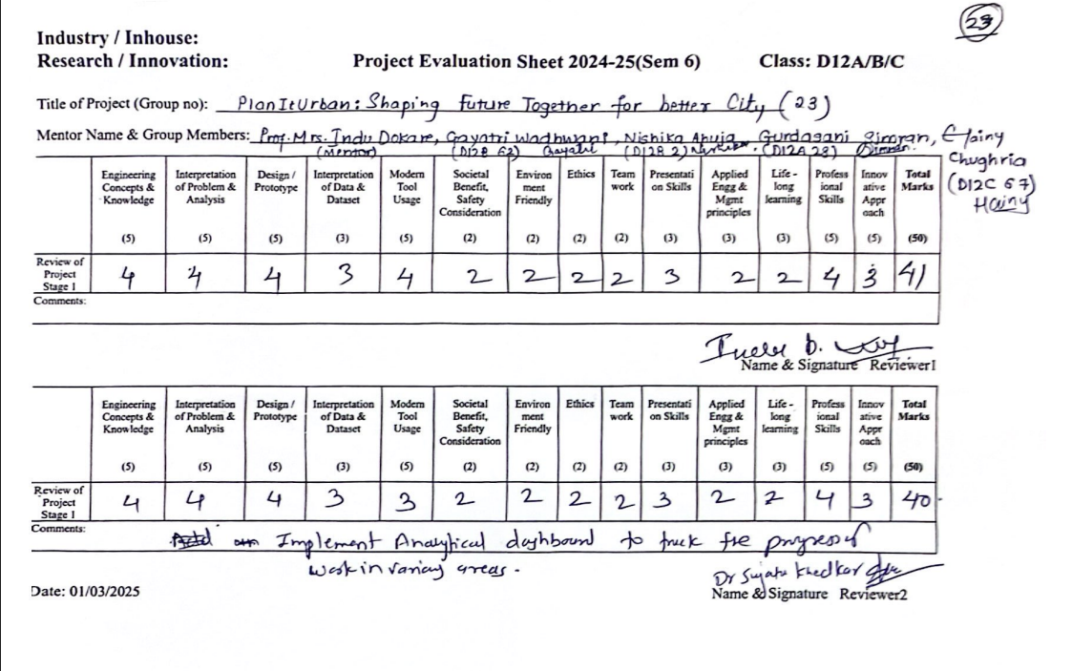

**Review-2 Sheet**

